Chapter 22
Emergency Medical Care for
Fire Department First Responders

Lesson Goal
After completing this lesson, the student shall be able to describe the role of the fire service in emergency medical care , laws regarding patient confidentiality, infection control practices, patient assessment, CPR, bleeding control, and shock management.
Objectives
Upon successful completion of this lesson, the student shall be able to:
1. Describe the roles the fire service may take in providing emergency medical care. [NFPA® 1001, 4.3]
2. Summarize patient confidentiality requirements. [NFPA® 1001, 4.3]
3. Distinguish among commonly encountered communicable diseases. [NFPA® 1001, 4.3]
4. Summarize immunization considerations for first responders. [NFPA® 1001, 4.3]
5. Explain the importance of body substance isolation (BSI). [NFPA® 1001, 4.3]
6. Explain actions taken for basic patient assessment. [NFPA® 1001, 4.3]
7. Compare and contrast CPR techniques for adults, children, and infants. [NFPA® 1001, 4.3]
8. Explain when to administer and when to discontinue CPR. [NFPA® 1001, 4.3]
9. Describe basic types of external bleeding. [NFPA® 1001, 4.3]
10. Explain the use of direct pressure and elevation to control external bleeding. [NFPA® 1001, 4.3]
11. Describe the signs and symptoms of internal bleeding. [NFPA® 1001, 4.3]
12. Describe the role that recognizing the types, signs, and symptoms of shock plays in shock management. [NFPA® 1001, 4.3]
Instructor Information
This is the lesson covering emergency medical care for fire department first responders. This lesson describes the role of the fire service in providing emergency care and laws regarding patient confidentiality. The lesson also covers infection control, patient assessment, CPR, bleeding, and shock.

Important instructor information is provided in shaded boxes throughout the lesson plan. Carefully review the instructor information before presenting the lesson.

The information contained in this lesson covers topics that are related to the entrance requirements for firefighter training required by NFPA® 1001. However, it is not meant to substitute for formal training as an emergency medical care provider.

Methodology
This lesson uses lecture and discussion. The level of learning is comprehension.
Outline Contents

Section | Outline Pages | Text Pages
Section I: Fire Service-Based Emergency Medical Care | 6 | 1272
Section II: Patient Confidentiality | 9 | 1272
Section III: Infection Control | 12 | 1273
Section IV: Patient Assessment | 29 | 1280
Section V: Cardiac Arrest and Cardiopulmonary Resuscitation (CPR) | 33 | 1282
Section VI: Bleeding Control | 47 | 1288
Section VII: Shock Management | 55 | 1292
Section VIII: Summary and Review | 59 | 1294

Audiovisuals
- Visuals 22.1 to 22.63 (PowerPoint® Presentation)
Evaluation
- Chapter 22 Quiz
- Chapter 22 Test
Presentation Tools
Interactive Objects allow instructors to present information a piece at a time by clicking on hot spots in a larger image.
Each object is labeled in the Lesson Outline and indicated in the PowerPoint® presentation by a RED arrow in the top left corner of the image. This lets instructors know to use the mouse to explore all of the information on the slide.

After all of the information is displayed a reset arrow will appear in the bottom right corner of the image. Instructors can use this to remove the text and quiz students on content just covered or simply move on to the next slide.
To move to the slide after an interactive object, select the Click for next slide arrow on the left side of the slide.

Videos are used as discussion starters or to illustrate a concept or process discussed in the chapter.
These are labeled in the Lesson Outline and indicated in the PowerPoint® presentation by the Click image to play arrow on the left side of the slide.

Section I: Fire Service-Based Emergency Medical Care

fire service-based emergency medical care
p. 1272 Objective 1 — Describe the roles the fire service may take in providing emergency medical care.
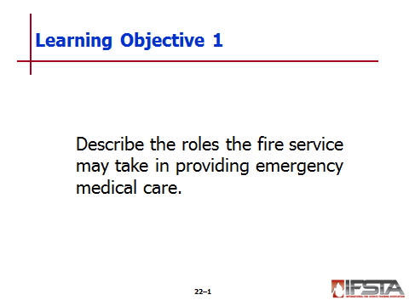Ask Students: Why are firefighters often cross-trained as emergency medical technicians (EMTs) or Paramedics?
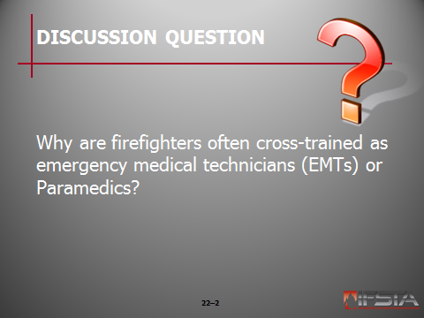Briefly discuss answers with students. Students may respond that firefighters may be responsible for emergency medical care either as part of an ambulance service or as first responders to the scene of a medical emergency.

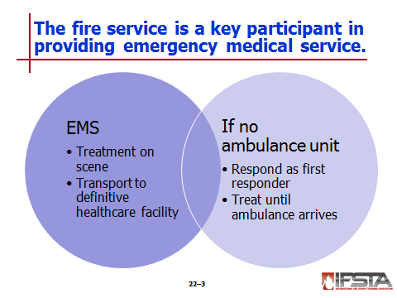Fire Service-Based Emergency Medical Care

Emergency medical service (EMS) –Treatment on scene and transport of victims who are ill or injured to definitive healthcare facility

Only had formal recognition since 1960s

Fire service is key participant

Provide EMS in a number of different ways

If organization does not operate ambulance units, personnel often respond as medical first responders to begin treatment until an ambulance arrives

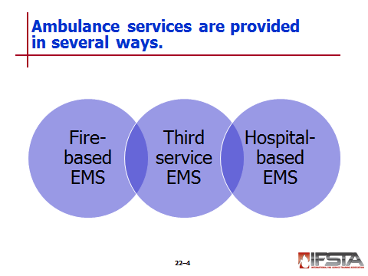Ambulance services provided in several ways

Fire-based EMS – Service provided as a function of fire department

Staffing by firefighters who cross-trained as emergency medical technicians (EMTs) or Paramedics

In some instances - Staffing provided by EMTs and Paramedics with no fire fighting responsibilities

Third-service EMS – Service provided by organization separate from fire and police services

Has own administration and personnel

In most instances, organization is function of municipal, county, provincial, or regional government

May also be provided by for-profit or not-for-profit organization under contract

Hospital-based EMS – Service is contracted to hospital by local government

Personnel are employees of hospital

Patients are typically transported to contracted hospital for treatment

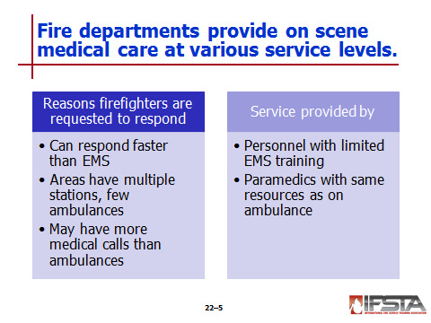Reasons fire departments are often requested to respond to scene and begin care until EMS personnel arrive

Fire department personnel often able to respond faster than EMS in many jurisdictions

Most areas have multiple fire stations and apparatus but only few ambulances

Areas may have more medical calls than ambulances available

Service level – May be provided

By personnel with limited EMS training

By paramedics who carry most of same equipment and medications on fire apparatus as are on ambulance

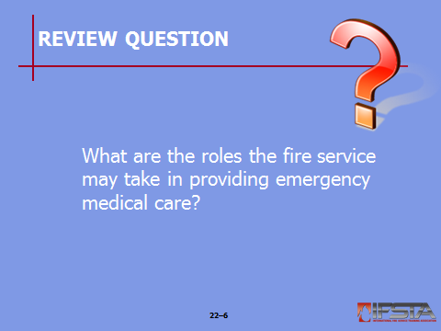Review Question: What are the roles the fire service may take in providing emergency medical care?
See p. 1272 of the manual for answers.

Section II: Patient Confidentiality

patient confidentiality
pp. 1272-1273 Objective 2 — Summarize patient confidentiality requirements.
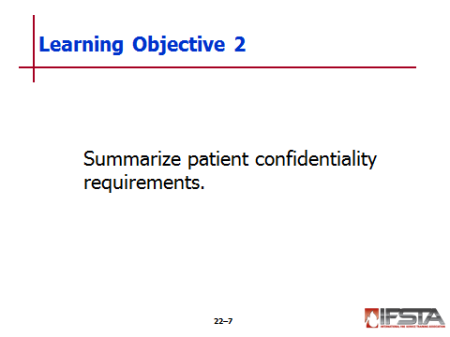Ask Students: What information is included in the protected medical information (PMI) of a patient?
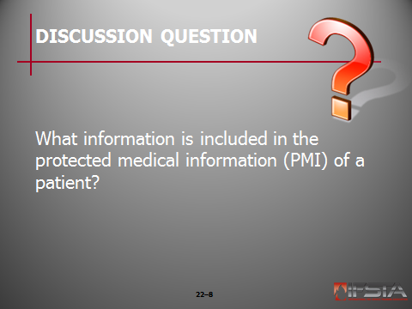In the discussion students should understand that the information includes: personal data (name, birth date, social security number, address), medical history, and condition. Also emphasize why it is important for this information to be kept confidential.

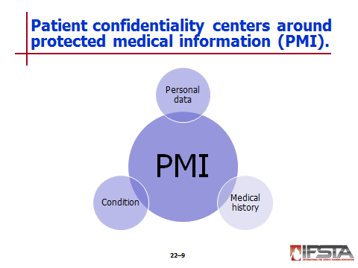Patient Confidentiality

Healthcare providers must safeguard protected medical information (PMI)

Personal data (name, birth date, social security number, address)

Medical history

Condition

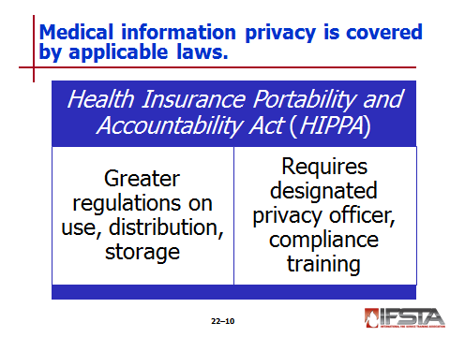Actions governed by applicable laws

Health Insurance Portability and Accountability Act (HIPAA) (1996) – Instituted greater regulations on use, distribution, storage of PMI

Establishes civil and criminal penalties for noncompliance

Fire departments typically required to follow regulations – If providing medical care and bill electronically for services

Regulations dictate

How and to whom PMI can be shared

How information is protected from unauthorized disclosure

Departments bound by HIPAA regulations are required to

Have designated privacy officer

Provide compliance training

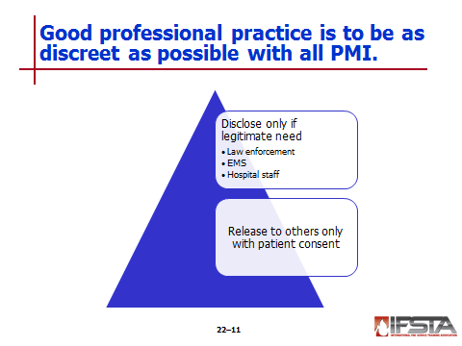Regardless of department’s obligations – Good professional practice is to be discreet as possible with PMI

PMI should only be disclosed to those who have a legitimate need

Law enforcement personnel

EMS personnel

Hospital staff

Release to other individuals can only be done with consent of patient
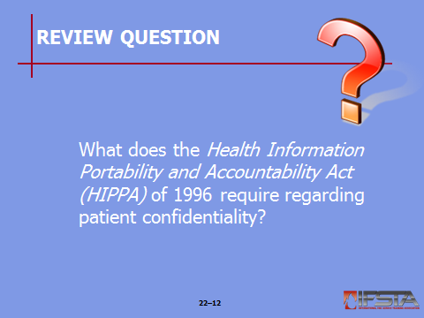Review Question: What does the Health Information Portability and Accountability Act (HIPPA) of 1996 require regarding patient confidentiality?
See p. 1272 of the manual for answers.

Section III: Infection Control

infection control
pp. 1273-1280 Objective 3 — Distinguish among commonly encountered communicable diseases.
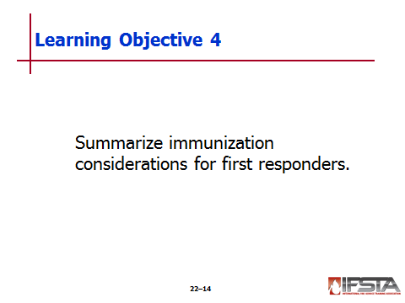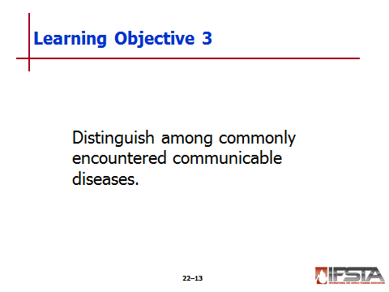 Objective 4 — Summarize immunization considerations for first responders.

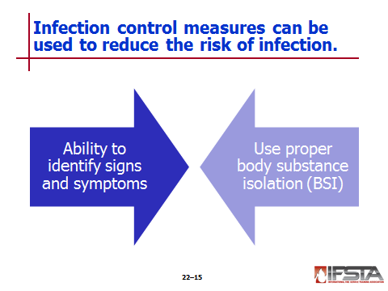 Infection Control

Communicable diseases not always obvious

Reduce risk of infection

Ability to identify signs and symptoms of common communicable diseases

Use proper body substance isolation (BSI)

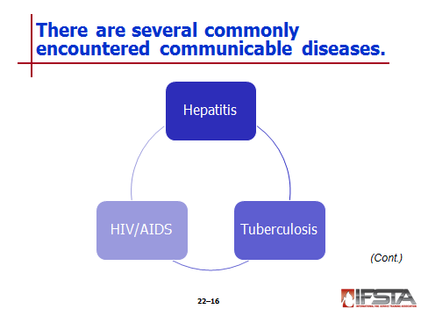Commonly Encountered Communicable Diseases

Hepatitis – Inflammation of the liver

Kinds encountered

Viral most common

Can be caused by drugs, alcohol, hazardous chemicals, heredity

Symptoms include

Viral-like illness

Yellowish discoloration of eyes and skin

Types of viral hepatitis

Hepatitis A – Typically caused by consuming food or water that has been contaminated, particularly by fecal matter

Signs and symptoms

Fatigue

Abdominal pain

Fever

Dark urine

Marked yellowing of the skin and/or eyes

Generally short-term; typically no long-term consequences

Least serious form of viral hepatitis

Hepatitis B – Typically transmitted through blood and other body fluids

Can be short-term or long-term

Can potentially cause serious scarring and injury to liver

Can eventually progress to liver failure

Signs and symptoms of Hepatitis B similar to those of Hepatitis A

Serious and potentially life-long infection

Hepatitis C – Typically transmitted through blood and other bodily fluids

Differs from other types

Those infected can go for years without exhibiting symptoms

Virus has more than likely done serious liver damage even while individual is symptom free

Damage can be long-term or permanent

Liver failure can occur

Hepatitis D (Delta) – Uncommon rare strain of hepatitis

Only occurs when also infected by Hepatitis B

Makes effects of Hepatitis B much worse

Vaccines

Available for Hepatitis A and B; those for Hepatitis C still in development stage

Important to be immunized against hepatitis and other infectious diseases

Best way to combat

Thoroughly wash hands

Maintain proper BSI procedures

Tuberculosis (TB) – Bacterial infection that primarily affects respiratory system

Contagious, spread through droplets in air produced by breathing and coughing of infected person

Bystanders have chance of becoming infected when droplets inhaled

Because transmitted by airborne droplets – Incidences more prevalent in high-density living areas

Considered active when exhibiting signs and symptoms

Fever

Fatigue

Chills

Weight loss

Painful breathing

Productive cough (often with traces of blood)

Coughing that lasts several weeks

Because signs and symptoms often similar to other illnesses – Take BSI precautions, use a N-95 mask, even if patient is not known to be infected

No widely used vaccine to protect against

Healthcare providers typically skin tested to check for occupational exposure annually

HIV/AIDS – Result of prolonged exposure to human immunodeficiency virus (HIV)

Weakens immune system to point where body is unable to fight off diseases

Symptoms

Early– Similar to other viral illnesses

More advanced – Lead to severe muscle wasting, increased likelihood of contracting other infections

Because of weakened immune defense – Also likely to be infected by diseases such as hepatitis and TB

Spread through contact with infected blood and body fluids

Pose less risk than hepatitis and TB

Due to short amount of time HIV can survive outside of body

Still important to

Practice proper BSI procedures

Adequately decontaminate any medical equipment before used on another patient
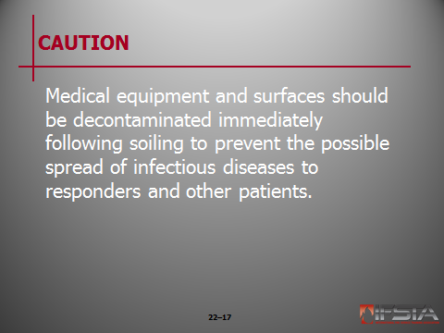Caution: Medical equipment and surfaces should be decontaminated immediately following soiling to prevent the possible spread of infectious diseases to responders and other patients.

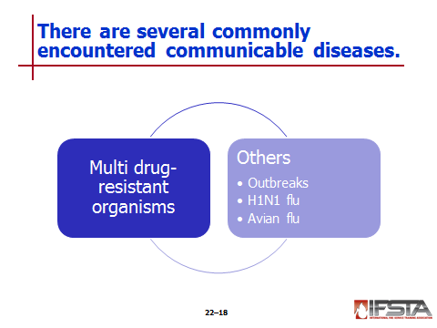Multi Drug-Resistant Organisms (MDRO)

Increasing concern in healthcare settings

Difficult to control

Do not typically respond to normal antibiotic treatment

Methicillin resistant staphylococcus aureus (MRSA) – Drug-resistant staph infection that is commonly encountered type of MDRO

Typically occur in healthcare settings, have been more recent outbreaks in communities

Can develop in numerous ways but are usually initially seen as abscesses in skin commonly mistaken for spider bites

Are easily spread – Important that proper BSI precautions be taken

All reusable medical equipment must be sanitized after each use to prevent from spreading

Other diseases

Outbreaks of infectious disease occur from time to time

Recent outbreaks in North America include

H1N1 influenza (“swine flu”)

Avian influenza (“bird flu”)

Others

Keep yourself and patients safe – Use proper sanitation and BSI procedures

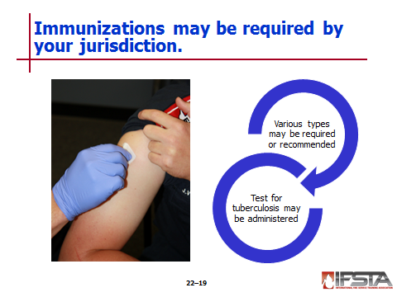Immunizations

May be required by jurisdictions

Types that may be required or recommended

Hepatitis B

Measles, mumps, and rubella (MMR)

Varicella (chickenpox)

Tetanus/diphtheria

Influenza

Annual purified protein derivative (PPD) test may be administered to determine tuberculosis exposure

Performed by injecting inactive bacterium under skin

Reaction to test may indicate tuberculosis exposure
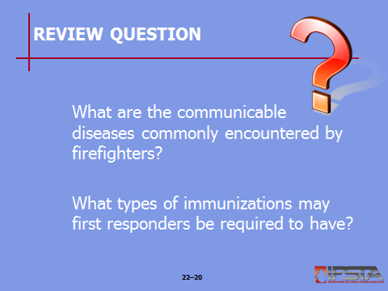Review Questions:
What are the communicable diseases commonly encountered by firefighters?
See p. 1274 of the manual for answers.

What types of immunizations may first responders be required to have?
See p. 1277 of the manual for answers.
pp. 1277-1280 Objective 5 — Explain the importance of body substance isolation (BSI).

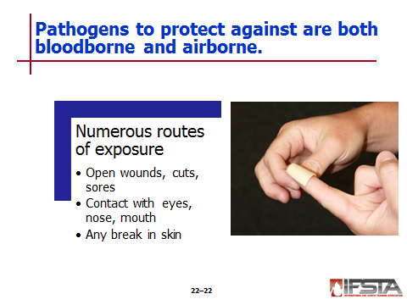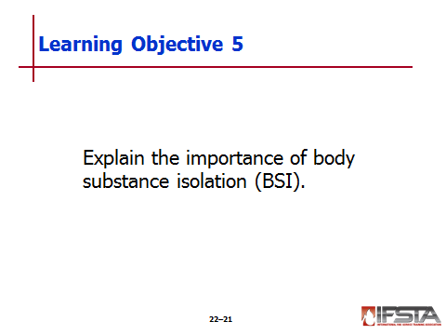Body Substance Isolation (BSI)

Pathogens – Organisms that carry disease and can cause infection

Exist in body fluids of infected persons

Can be transmitted from one person to another through contact with these fluids

Any type of body fluid can carry pathogens

Bloodborne pathogens are most commonly encountered

Main types

Bloodborne most commonly encountered – Though any type of fluid can carry

Airborne – Spread by tiny droplets when infected individual coughs or breathes

Exposure occurs when body fluid of infected individual comes in contact with exposed area of another person

Numerous routes where emergency responders are susceptible to exposure

Open wounds, cuts, and sores on body

Contact with eyes, nose, or mouth

Any break in skin is potential route of exposure

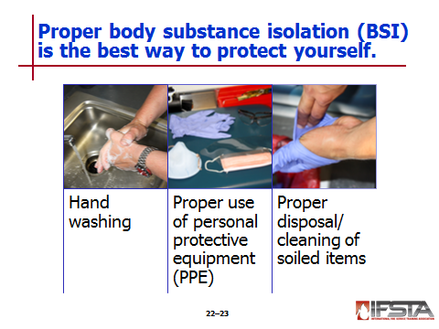Critical that firefighters take all precautions necessary to protect from exposure – Best way is by maintaining proper BSI procedures

Hand washing

Proper use of personal protective equipment

Proper disposal and/or cleaning of soiled items

Sources of information for establishing BSI procedures

United States Centers for Disease Control and Prevention (CDC)

Canadian provincial health authorities

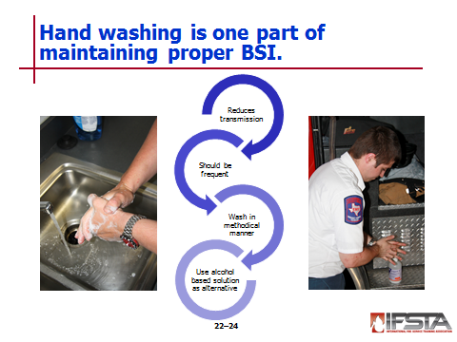Hand washing must be performed regularly

Proper hand washing has been shown to greatly reduce transmission of disease

Should be done frequently; especially before and after coming in contact with a patient

Hands should be washed in methodical manner with warm water and soap

Special attention paid to areas on hands that are soiled, areas between fingers, fingernails

Good practice to wash wrists and forearms

Hands should be washed for no less than 30 seconds

Hand washing is often not an option when responding to emergency calls

Alcohol-based hand cleaning solution should be used

Especially after providing patient care

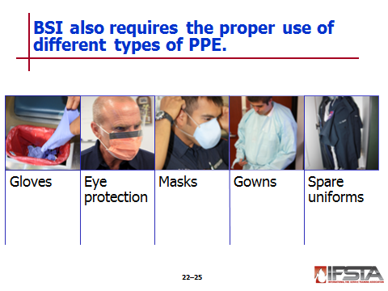Personal Protective Equipment (PPE) – Use to prevent transmission of infectious diseases

When selecting – Better to wear too much than not enough

Refer to department SOPs regarding use on emergency medical responses

Types of PPE

Gloves – Should always be worn during patient contact

In the past, medical gloves were typically made of latex

Some patients and healthcare providers have allergic reaction to this material

Many jurisdictions supply emergency responders with gloves made of vinyl or other materials

If jurisdiction uses latex gloves, ask patient if he or she has a latex allergy; nonlatex gloves should be available

The same gloves should never be used when treating multiple patients

To remove soiled gloves, place two clean fingers on inside of glove and peel off

Gloves soiled with blood or other body fluids should be disposed of in sealed container

Specifically used for disposal of biohazards

Typically red in color and have a red liner

Eye protection – Especially necessary when there is chance for blood or other body fluids to be splashed, sprayed, or spattered

Safety glasses are a common type used

Designed to keep fluids away from eyes

Usually provide some type of impact resistance

Accessories are available for those who wear prescription glasses

Combination mask and eye shield available and widely used

Helmet shields and Bourke eye shields do not provide suitable eye protection for emergency medical use

Masks – Protect against respiratory hazards, airborne pathogens, body fluids

Surgical-style masks typically suffice in situations where contact with blood or other body fluids are concern

Use mask that provides greater level of protection if you suspect patient has communicable respiratory disease

Placing mask on patient can also prevent transmission of disease to others

N-95 respirators may be provided for use when treating patients where TB suspected

Termed N-95 because are tested and shown to block at least 95 percent of airborne particles

Gowns – Protect exposed skin and uniform from spray and spatter of body fluids

Spare uniforms – Departments may require extra uniform ensemble available at station or on apparatus

Soiled uniform looks unprofessional, can potentially allow for spread of disease

Follow departmental guidelines with regard to cleaning

In instances of extreme contamination, immediately shower and notify infection control officer

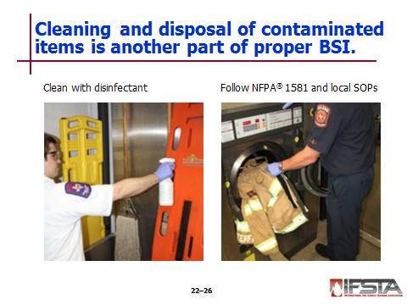Cleaning and disposing of contaminated items

Medical equipment and non-disposable PPE that comes into contact with any patient must be considered contaminated

Must follow requirements of NFPA® 1581 and department’s infection control protocol

General steps for decontaminating equipment and PPE

Wear disposable gloves, mask, eye protection to place contaminated items in biohazard bag or container

Transport contaminated items to designated disinfecting area of fire station or other facility

Don appropriate splash-resistive eyewear, cleaning gloves, and fluid-resistant clothing designated for decontaminating equipment

Use solution of bleach and water or disinfectant in accordance with equipment or PPE manufacturer’s instructions

Do not decontaminate equipment or PPE in kitchen, bathroom, or other living areas of fire station

Contaminated station uniforms or structural PPE must not be taken home or cleaned in normal laundry facilities

Decontaminate sink and cleaning area, remove PPE worn during cleaning, and dispose of in accordance with fire department protocol

Contaminated disposable equipment and PPE must be placed in medical waste containers and disposed of in accordance with local protocol

Needles and blades, must be placed in sharps containers designated for such items

Containers must be closable, puncture-proof, leak-proof

Labeled according to federal, state, or local regulations
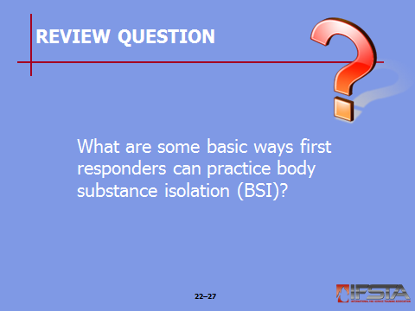Review Question: What are some basic ways first responders can practice body substance isolation (BSI)?
See pp. 1278-1280 of the manual for answers.

Section IV: Patient Assessment

patient assessment
pp. 1280-1282 Objective 6 — Explain actions taken for basic patient assessment.

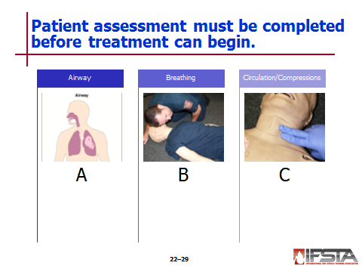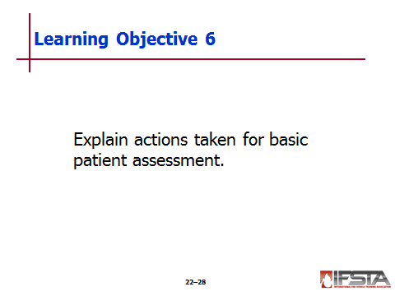Patient Assessment

Patient condition must be assessed before medical treatement can begin

Most basic assessment – determine if critical functions of body are working properly

If patient is responsive, assessment involves evaluation of airway, breathing, and circulation

Known as the ABCs

Majority of patients will be responsive and assessed in this manner

In patients that are unresponsive and not breathing, or breathing with irregular gasping breaths, assessment sequence should be rearranged

Circulation, Airway, then Breathing (CAB)

Change is based on research that shows that any delay in delivery of high quality chest compressions reduces likelihood of successful resuscitation from cardiac arrest

If pulse present – Assess airway and follow normal ABC sequence

If no pulse found

Immediately begin cycle of chest compressions

Then open airway and ventilate patient – Cardiac arrest CAB sequence
Instructor Note: Discuss with students the fact that formal CPR training will provide more definitive information on the performance of assessment techniques.

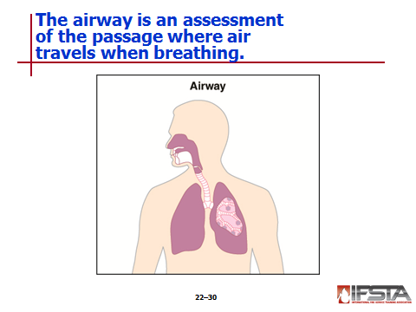Airway

Airway – Passage between lungs and nose and mouth where air travels during breathing

If obstructed by tongue, a foreign object, or fluid, air cannot travel freely

If patient is able to talk and appears to be breathing without difficulty, can be assumed that airway is clear

If the patient is unresponsive, you may need to perform a technique to open airway
Instructor Note: Discuss with students the fact that techniques for opening the airway are introduced during formal CPR training.

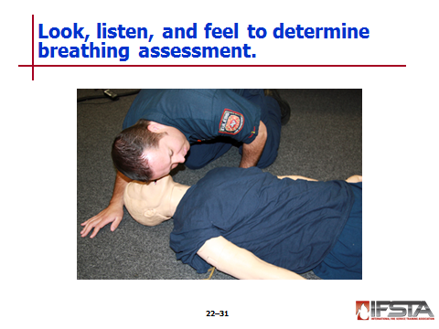Breathing

After determining airway is open, necessary to determine if patient is breathing

Best way to determine is to look, listen, and feel for breathing by placing ear near patient’s nose and mouth and looking at chest

Should see patient’s chest rise and fall with each breath

When listening, should be able to hear patient breathing through mouth or nose

When feeling, should be able to feel exhaled air

If patient is not breathing or no air is being moved during breathing, you will need to provide assistance
Instructor Note: Discuss with students the fact that techniques for rescue breathing are introduced during formal CPR training.

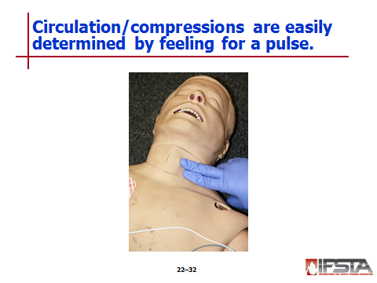Circulation/Compressions

Circulation – Flow of blood through body

Easiest way to determine by feeling for pulse

Most pulses assessed at radial and carotid arteries

Because of distance of radial artery from heart, it typically takes stronger blood flow for pulse to be felt in this area than at carotid artery

Just because pulse cannot be found at radial artery does not mean that patient is pulseless

In these instances, you should attempt to find pulse at carotid artery as well

If pulse cannot be found, chest compressions should be initiated immediately
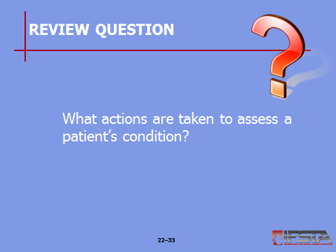Review Question: What actions are taken to assess a patient’s condition?
See pp. 1280-1282 of the manual for answers.

Section V: Cardiac Arrest and Cardiopulmonary Resuscitation
(CPR)

cardiac arrest and cardiopulmonary resuscitation (CPR)
pp. 1282-1288 Objective 7 — Compare and contrast CPR techniques for adults, children, and infants.
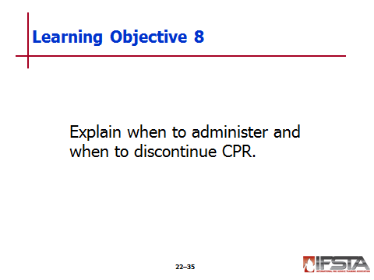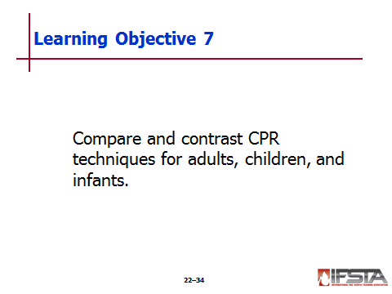 Objective 8 — Explain when to administer and when to discontinue CPR.

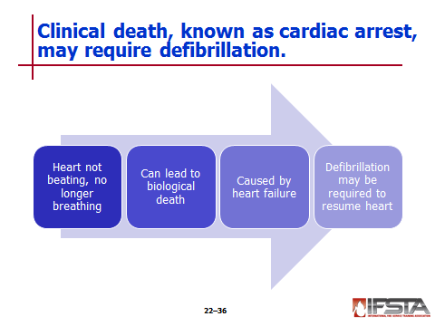Cardiac Arrest and Cardiopulmonary Resuscitation (CPR)

Clinical death – When patient’s heart stops beating and they are no longer breathing

Condition known as cardiac arrest

Heart fails to circulate blood through body

Cells not able to receive oxygen and nutrients needed to survive – Begin to die in span of few minutes

If allowed to continue

Cell death will progress to point where organs (brain, heart, lungs) irreversibly damaged and cannot be revived

Leads to biological death – No medical intervention can revive patient at this point

Electrical impulses in heart – Cause it to contract and force blood throughout body

Heart failure that causes clinical death often result of problem with heart’s ability to produce, transmit impulses

Condition often persists unless outside electrical stimulus applied

Outside stimulus commonly known as defibrillation

Heart will often not resume operation without defibrillation – Critically important that it be done as soon as possible

Advanced-level EMS providers trained to

Recognize electrical issues with heart

Manually administer defibrillation and medications that treat these issues

May take several minutes for these personnel to arrive on scene

During this time, patient may have already transitioned from clinical death to biological death

Automated external defibrillators (AEDs) available for layperson use in public facilities – Device will

Instruct layperson on how to use

Automatically determine if defibrillation is needed

Notify user to push button that delivers shock

Also common to find AEDs on fire apparatus that do not carry Paramedics and their equipment
Instructor Note: Discuss with students that the use of AEDs is beyond the scope of this chapter; however, the students’ department will provide further training if they are expected to use AEDs during medical responses.

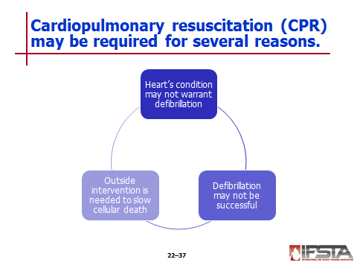Cardiopulmonary resuscitation (CPR) – Act of physically forcing blood through a patient’s body and providing artificial respiration

In some instances, heart’s condition may not warrant defibrillation

In others, defibrillation may not be successful in resuming function of heart

Outside intervention is needed in order to circulate blood through body and slow rate of cellular death
Instructor Note: Discuss with students that the information presented highlights how to perform layperson CPR on adults, infants, and children. Emphasize that layperson CPR is performed in a different manner than CPR for healthcare providers. In particular, a higher priority is placed on chest compressions than patient assessment. Remind students that it is imperative that they participate and are certified in a CPR course administered by their department and/or the American Heart Association if they are to provide this type of care.

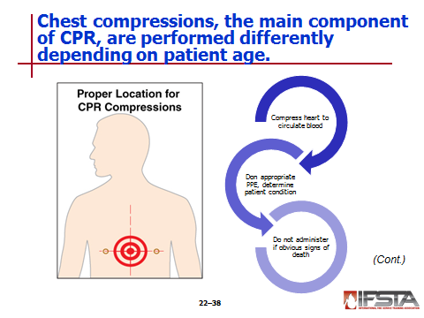Chest Compressions

Chest compressions

Main component of CPR

Act of forcefully compressing heart in order to circulate blood throughout body

When performed properly, chest compressions

Compress heart between patient’s sternum and spine in rapid succession

Alter pressure within chest, forcing blood from heart

Chest compressions performed in different ways and at different rates and depths, depending on age of patient

Administering chest compressions

First priority after donning appropriate PPE – Determine condition of patient

While CPR is lifesaving intervention, it should not be administered to those who have obvious signs of irreversible death – These include

Rigor mortis

Obvious wounds that are not compatible with life (such as decapitation)

Decomposition

Line of lividity
Instructor Note: Discuss with students that the techniques identified in this chapter are for layperson CPR. As such, there is a greater emphasis on providing chest compressions than providing ventilation. Therefore, rescue breathing will not be addressed in this chapter. Full CPR incorporates both chest compressions and rescue breathing. Most emergency responders are certified in CPR to the Basic Life Support (BLS) for Healthcare Providers-Level. Emphasize that it is critical to attend and obtain certification from a formal CPR training course.

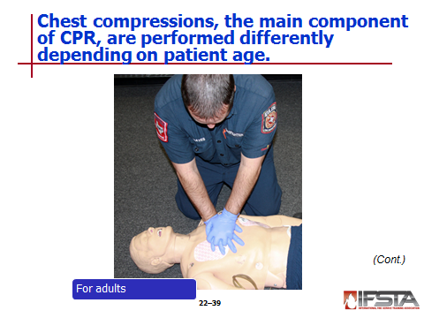Chest compressions for adults

Upon arrival for suspected cardiac arrest – Identify patient and determine status

First determination – If patient is conscious or unconscious

Can be performed by gently shaking or tapping patient and asking them if they are OK

If no physical or verbal response, determine if patient has pulse

If no pulse can be found at radial or carotid arteries, chest compressions should be started

Communications center should be notified of condition and any additional resources that are needed

When performing chest compressions on adult – Must first be lying on their back on hard surface such as floor or backboard

If patient lying in bed, should be moved to floor

Performing chest compressions on someone lying on soft surface is typically ineffective

Next, find correct location to administer compressions – Center of patient’s chest between nipples

To perform compressions, place one hand on top of other and complete following steps

Step 1 – Straighten arms and lock elbows; elbows should remain locked while performing compressions

Step 2 – Align shoulders directly over hands; ensures that compressions are delivered straight down

Step 3 – Press straight down on chest hard enough to depress sternum at least 2 inches (50mm)

Step 4 – Release compression by lifting up; keep elbows locked at all times and do not remove hands from compression location

Compressions should be administered by quickly and firmly depressing chest at rate of at least 100 compressions per minute

Responders should rotate performance of chest compressions as needed to prevent exhaustion

Compressions should be continued until

Patient moves or regains consciousness

Responders with greater training arrive

Chest compressions should be performed in a rhythmic manner; should never feel as though you are jabbing at the patient

Possible that some type of cracking of sternum or ribs may be heard or felt during compressions – This is normal
NOTE: While performing chest compressions, it is often common to hear or feel a patient's ribs break due to the pressure. While this sensation is not pleasant, it is a sign of good quality compressions and should not discourage you from continuing.

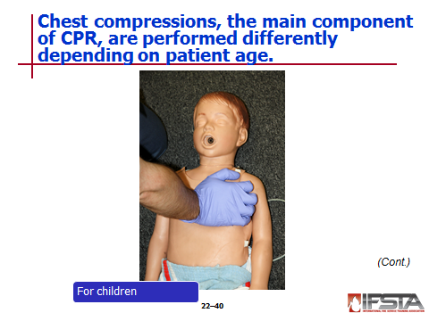Chest compressions for children

When arriving on scene for cardiac arrest involving child, first determine patient’s status

Gently shake or tap child to determine if they are conscious

Speak to child and see if they respond

If patient is unresponsive, check for pulse; if no pulse can be found, begin chest compressions

Move patient to floor or place them on backboard if not lying on solid surface

Update dispatch with condition, request any additional resources

Chest compressions are performed for children ages 1-8 in slightly different manner than those for adults

Instead of performing compressions with 2 hands, rescuers should only use one hand

Hand should be placed in center of chest in-line with patient’s nipples

When performing compressions, patient’s chest should be compressed about 1/3 depth between chest and back or about 2 inches (50 mm)

Compressions should be administered firmly and quickly at rate of at least 100 compressions per minute

Continue administering compressions until

Child begins to move, regains consciousness

Rescuers with greater training arrive

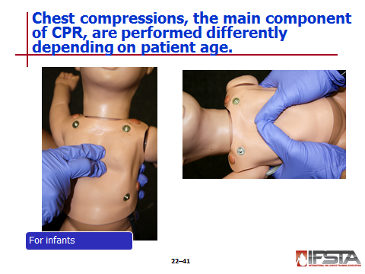Chest compressions for infants

When responding to cardiac arrest in infant patient (less than one year old), first determine patient’s status

Most incidences of cardiac arrest in infants are due to airway obstructions

If obstruction can be seen in mouth, remove it

If not, continue in determining patient’s status by speaking to and stroking infant and looking for any type of movement or other response

If there is no response, check for pulse

If no pulse can be found, begin chest compressions

Have another responder update dispatch on patient’s status, request any additional resources

Chest compressions for infants are performed with index and middle fingers of one hand – Allows chest to be better compressed than with heel of hand

As with adults and children, compressions should be delivered in center of chest in-line with patient’s nipples

Compressions should be delivered at rate of at least 100 compressions per minute; infant’s chest should be compressed to 1/3 depth of torso – About 1.5 inches (38 mm)

Periodically check patient’s mouth to see if any foreign bodies are present

If so, remove from mouth and reassess

If not, continue performing compressions until infant begins to move, regains consciousness, or until responders with greater training arrive

Can also be performed in “around the chest” manner

Where thumbs are used to perform compressions

Same compression rate and depth as traditional method still applies
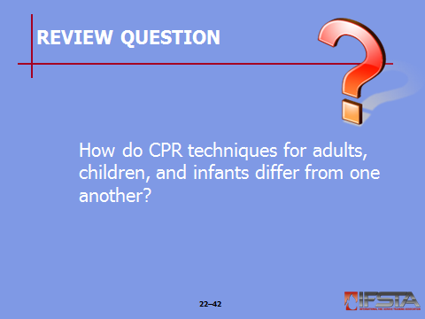Review Question: How do CPR techniques for adults, children, and infants differ from one another?
See pp. 1285-1287 of the manual for answers.

Discontinuing CPR

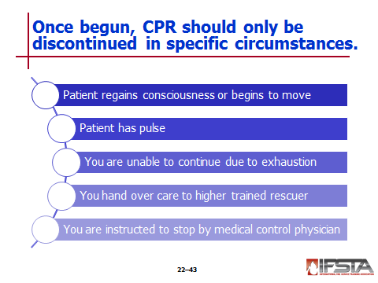Periodically reassess patient during CPR to determine if working

Main way – Patient regains consciousness or begins to move

Another way – Reassessing periodically for pulse

Discontinue CPR if patient regains consciousness, begins to move, or has pulse – Patient should be transported to definitive care facility

Once CPR is initiated, it should continue until one of following events occurs

Patient begins to move and/or regains consciousness

Patient has pulse

You are unable to continue due to exhaustion

You hand over care to rescuer with higher training

You are instructed to stop CPR by medical control physician

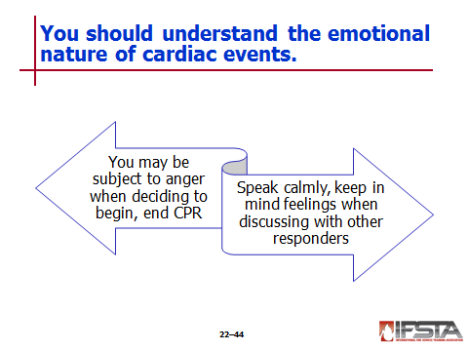Understand emotional nature of cardiac arrest events

May be subject to anger or emotional response when deciding not to begin or to discontinue CPR without patient response

Speak calmly, keep in mind feelings when discussing patient with other responders
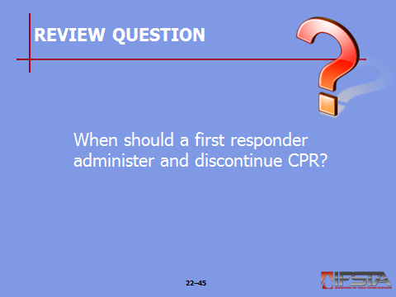Review Question: When should a first responder administer and discontinue CPR?
See p. 1288 of the manual for answers.

Section VI: Bleeding Control

bleeding control
pp. 1288-1291 Objective 9 — Describe basic types of external bleeding.
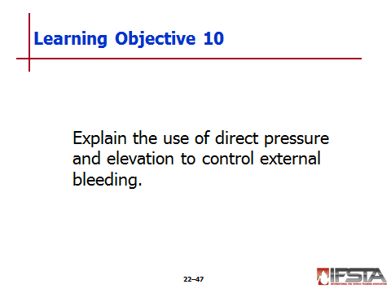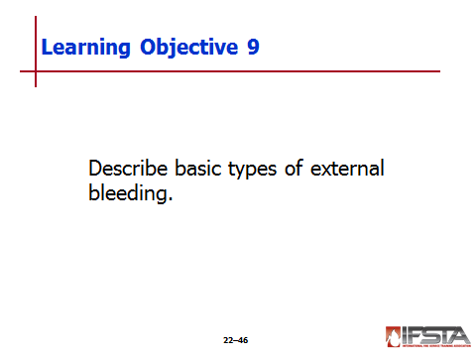 Objective 10 — Explain the use of direct pressure and elevation to control external bleeding.

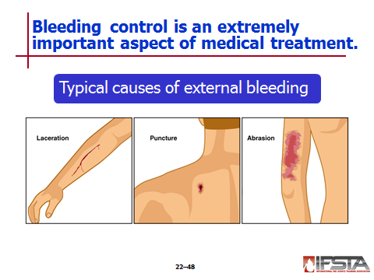Bleeding Control

Blood in body is critical to transport oxygen and nutrients to cells

Maintaining blood flow and volume is extremely important; emergency responders should be prepared to control bleeding

Two types of bleeding

External

Internal

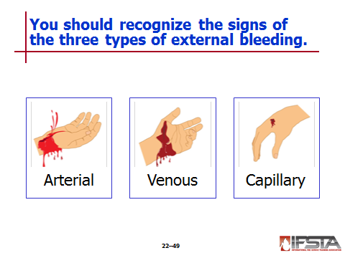Types of External Bleeding

External bleeding – Occurs outside body; typically caused by

Lacerations

Punctures

Other openings in skin

Three types of external bleeding

Arterial

Venous

Capillary

Arterial bleeding – Occurs when wall of artery has been ruptured

Blood is transported away from heart through vessels called arteries

Under high pressure

Bright red in color due to large amount of oxygen it contains

Arterial bleeding can be identified when blood is

Bright red

Spurting or pulsing

Spurting bleeding coincides with each contraction of heart

As significant quantities of blood are lost, force of blood decreases

Often difficult to control due to substantial force of the blood; is a true medical emergency

Patients with arterial bleeding have potential to lose substantial amount of blood in short period of time

Sometimes not possible to stop arterial bleeding without surgical intervention – Should be no delay in transporting patients with arterial bleeding to hospital by ambulance

Venous bleeding

Veins – Responsible for returning blood that has been used by cells back to heart

Blood movement through veins occurs at slow and steady flow

Venous bleeding is typically easier to control than arterial bleeding

Patients with venous bleeding will have steady flow of blood

Blood will be much darker than arterial blood because oxygen has been removed by cells; carbon dioxide and waste have been added

Capillary bleeding – Majority of injuries to capillaries come in form of scrapes or superficial lacerations

Capillaries – Areas between arteries and veins where oxygen and nutrients in blood are delivered to cells

Carbon dioxide and waste are removed by blood through capillaries

Because of this exchange, blood moves relatively slowly in capillaries

“Oozes” from injuries to capillaries and is typically of limited quantity

Not quite as dark as venous blood, but darker than arterial blood

Some capillary bleeding can stop on its own without outside intervention

Injuries provide an opportunity for infection and should be properly cleaned and bandaged
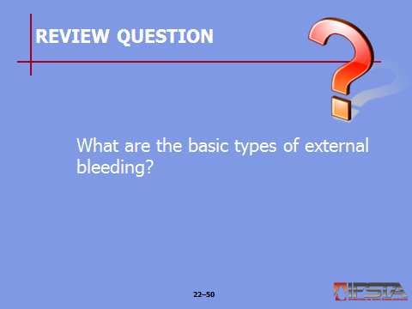Review Question: What are the basic types of external bleeding?
See p. 1288 of the manual for answers.

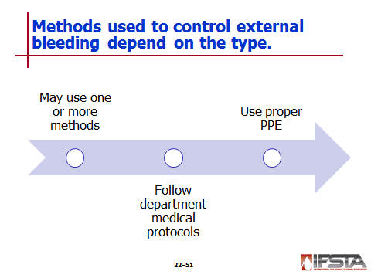Controlling External Bleeding

Methods for controlling bleeding
Instructor Note: Discuss with students the fact that tourniquets are also used to control bleeding by medical providers who are trained in their use. However, the use of tourniquets is beyond the scope of this chapter.

Depending on type of bleeding, one or more method may need to be used simultaneously

Always follow departmental medical protocols and recommended standards of patient care

Proper PPE must be used when treating patients with uncontrolled bleeding

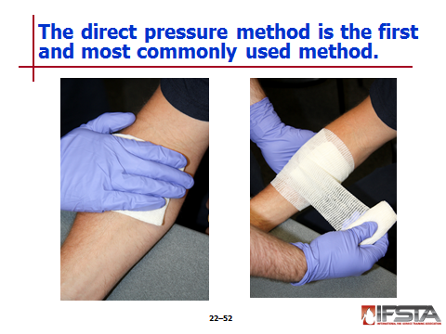Direct pressure – Pressure is applied directly to wound

First and most commonly used method to control bleeding

Can be applied with gloved hand, dressing, or with dressing and some type of bandage

With minor bleeding, application of dressing to wound may be all that is necessary to stop bleeding

In more severe instances of bleeding, especially arterial bleeding, direct pressure should be applied with gloved hand immediately

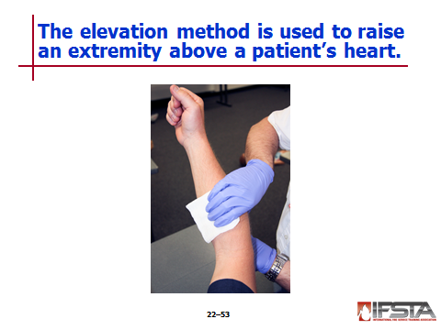Elevation – Act of raising extremity above level of patient’s heart

When injuries occur to extremities, elevation can be used in conjunction with direct pressure

Effect of gravity helps slow amount of blood traveling through extremity, in turn slowing bleeding

May not be possible in some instances, such as with fractures and injuries where spinal immobilization is needed
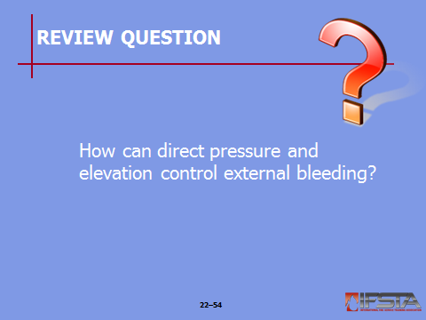Review Question: How can direct pressure and elevation control external bleeding?
See pp. 1290-1291 of the manual for answers.
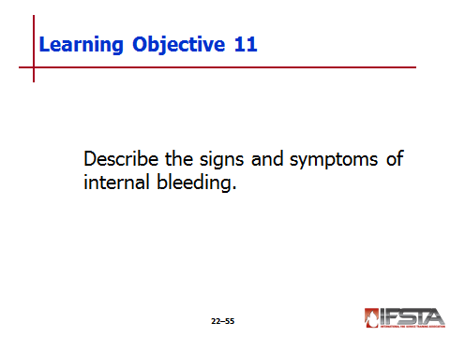pp. 1291-1292 Objective 11 — Describe the signs and symptoms of internal bleeding.

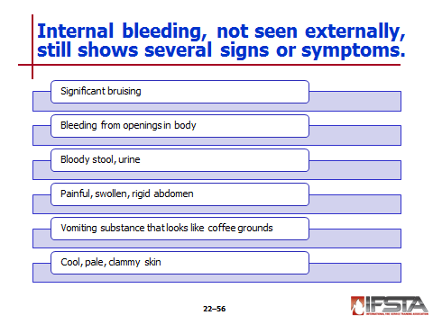Internal Bleeding

May occur when blood vessels rupture inside body

Dangerous because spaces within body can hold considerable amount of blood before there is evidence of problem

While not seen externally – Signs and symptoms that may show

Significant bruising or other indications of injury, especially involving patient’s torso

Bleeding from openings in body such as mouth, nose, or rectum

Bloody stool or urine

Painful, swollen, or rigid abdomen

Vomiting of substance that looks like coffee grounds

Cool, pale, and clammy skin

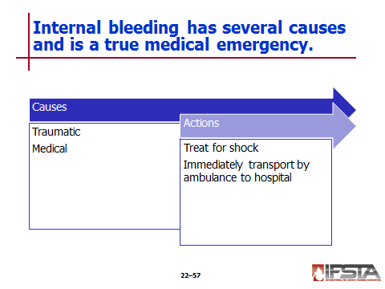Caused by both trauma and medical issues

Traumatic causes

Penetrating gunshot or stab wound

Motor vehicle accident

Fall

Medical causes – Include ruptured blood vessels or organs

Uncontrolled internal bleeding is true medical emergency

Patients with internal bleeding should be treated for shock

Patients who show signs and symptoms of internal bleeding should be immediately transported by ambulance to hospital for treatment

Section VII: Shock Management

shock management
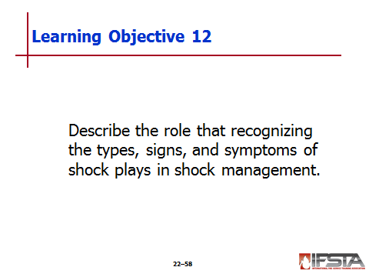pp. 1292-1293 Objective 12 — Describe the role that recognizing the types, signs, and symptoms of shock plays in shock management.

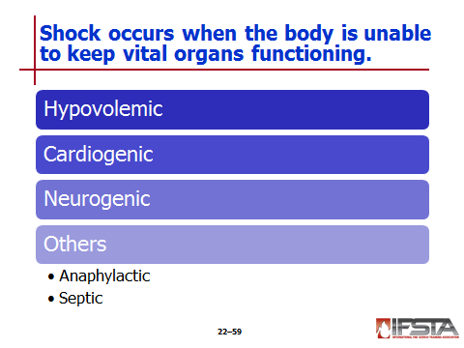Shock Management

Shock – Condition that occurs when body is unable to regulate itself and maintain normal function

Body in shock is unable to supply enough blood to vital organs to keep them functioning

Types of Shock

Hypovolemic shock – Caused by loss of blood

Body is unable to supply blood to tissue

Result of internal and/or external bleeding

“Volume” issue – Amount of blood in body substantially reduced

Majority of instances of shock

Cardiogenic shock – Caused by poor cardiac output

Occurs when heart is unable to force enough blood to tissue for it to continue functioning

“Pump” issue – Heart is unable to pump enough blood

Myocardial infarction (MI), also known as a heart attack – Main cause of heart impairment and can cause body to go into cardiogenic shock

Neurogenic shock – Caused by overexpansion of blood vessels due to damage to brain, spinal cord, or other nerves

Prevents body from controlling expansion and contraction of blood vessels

“Container” issue – Typically result of overexpansion of blood vessels; as vessels expand, pressure of blood decreases due to increased capacity

Common causes are spinal trauma and head injuries

Other types of shock

Anaphylactic shock – Caused by severe allergic reaction

Food allergies

Environmental allergies

Insect bites or stings

Septic shock – Caused by severe infection in body

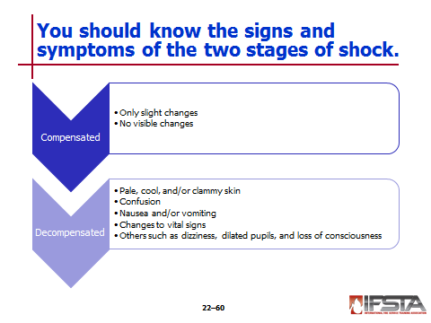Signs and Symptoms of Shock

Two stages of shock

Compensated – When body is affected by negative condition and is adjusting functions in order to maintain normal levels

Decompensated – When body is no longer able to adjust to maintain these levels

Compensated shock can often be difficult to identify because patient

May exhibit only slight changes (such as an increased pulse rate)

May exhibit no visible changes at all

When a patient is in decompensated shock, body will produce signs and symptoms that are readily identifiable – Signs and symptoms include one or more

Pale, cool, and/or clammy skin

Confusion

Nausea and/or vomiting

Changes to vital signs

Others such as dizziness, dilated pupils, and loss of consciousness

Whenever shock is suspected, patient should be quickly treated and prepared for transport by ambulance to hospital

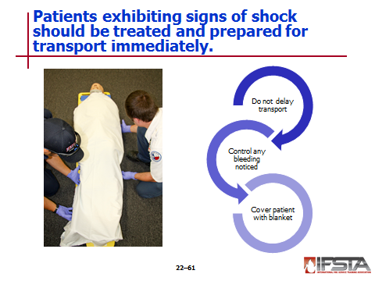Shock Treatment

Shock is life-threatening condition, patients exhibiting signs and symptoms should be

Treated immediately

Prepared for transport

Advanced life support treatments by paramedics are extremely important, but they should not delay transport to hospital

Transport to hospital can be viewed as treatment

In most cases it is best treatment that can be provided

Transport of any patient exhibiting symptoms of shock should never be delayed

Any bleeding that is noticed should be controlled immediately

Blanket should be used to cover patient in order to

Maintain body temperature

Prevent hypothermia

EMT Intermediates and Paramedics are able to provide other advanced treatments for shock in these instances
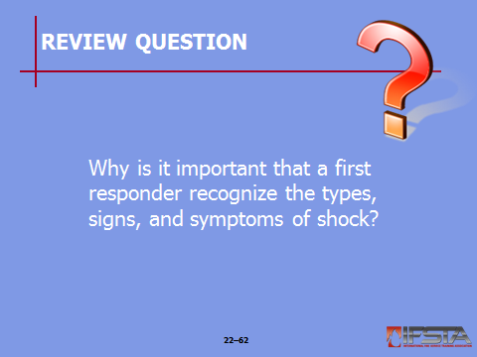Review Question: Why is it important that a first responder recognize the types, signs, and symptoms of shock?
See p. 1293 of the manual for answers.

Section VIII: Summary and Review

SUMMARY AND REVIEW

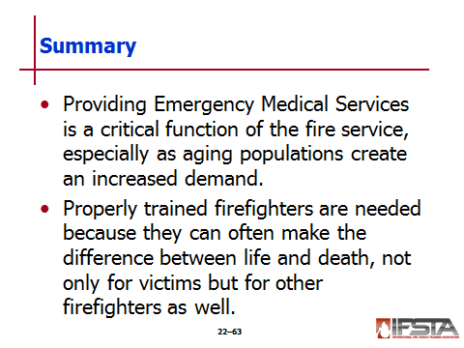Chapter Summary

Providing Emergency Medical Services is a critical function of the fire service; especially as aging populations create an increased demand.

Properly trained firefighters are needed because they can often make the difference between life and death, not only for victims but for other firefighters as well.

Review Questions

What are the roles the fire service may take in providing emergency medical care? (1272)

What does the Health Information Portability and Accountablity Act (HIPPA) of 1996 require regarding patient confidentiality? (1272-1273)

What are the communicable diseases commonly encountered by firefighters? (1274)

What types of immunizations may first responders be required to have? (1277)

What are some basic ways first responders can practice body substance isolation (BSI)? (1278-1280)

What actions are taken to assess a patient’s condition? (1280-1282)

How do CPR techniques for adults, children, and infants differ from one another? (1285-1287)

When should a first responder administer and discontinue CPR? (1288)

What are the basic types of external bleeding? (1288)

How can direct pressure and elevation control external bleeding? (1290-1291)

What are the signs and symptoms of internal bleeding? (1291)

Why is it important that a first responder recognize the types, signs, and symptoms of shock? (1293)

