Chapter 21
Fire and Life Safety Initiatives

Lesson Goal
After completing this lesson, the student shall be able to describe the role of a Firefighter I in the development and implementation of a fire and life safety program. Students will also be able to explain the process of selecting and delivering appropriate fire and life safety messages.
Objectives
Upon successful completion of this lesson, the student shall be able to:
1. Explain the steps taken during fire and life safety program development. [NFPA® 1001, 5.1.1]
2. Describe the components involved in fire and life safety program delivery. [NFPA® 1001, 5.1.1]
3. Explain the impact of safety hazards, messages, and target audiences on creating fire and life safety education programs. [NFPA® 1001, 5.1.1]
4. Indicate ways to identify and prevent firesetter development. [NFPA® 1001, 5.1.1]
5. Describe the role of a Firefighter I in enforcing fire and life safety codes. [NFPA® 1001, 5.1.1]
Instructor Information
This is the lesson covering the value of and process for developing a fire and life safety initiative program. This lesson describes categories of juvenile firesetters and messages that should be delivered to help community members identify indicators.

Important instructor information is provided in shaded boxes throughout the lesson plan. Carefully review the instructor information before presenting the lesson.

Methodology
This lesson uses lecture and discussion. The level of learning is comprehension.
Table of Contents
Section | Lesson Plan | Text
Section I: Program Value and Development | 5 | 1222
Section II: Program Delivery | 10 | 1224
Section III: Fire and Life Safety Education | 13 | 1226
Section IV: Fire and Life Safety Codes | 32 | 1237
Section V: Summary and Review | 35 | 1260

Audiovisuals/Handouts
- Visuals 21.1 to 21.36 (PowerPoint® Presentation)

Evaluation
- Chapter 21 Quiz
- Chapter 21 Test

Instructor Tools
Interactive Objects allow instructors to present information a piece at a time by clicking on hot spots in a larger image.

Each object is labeled in the Lesson Outline and indicated in the Power Point presentation by a RED arrow in the top left corner of the image. This lets instructors know to use the mouse to explore all of the information on the slide.


After all of the information is displayed a reset arrow will appear in the bottom right corner of the image. Instructors can use this to remove the text and quiz students on content just covered or simply move on to the next slide.

To move to the slide after an interactive object, select the Click for next slide arrow on the left side of the slide.

Videos are used as discussion starters or to illustrate a concept or process discussed in the chapter.

These are labeled in the Lesson Outline and indicated in the Power Point presentation by the Click image to play arrow on the left side of the slide.
Section I: Program Value and Development

Program Value and development
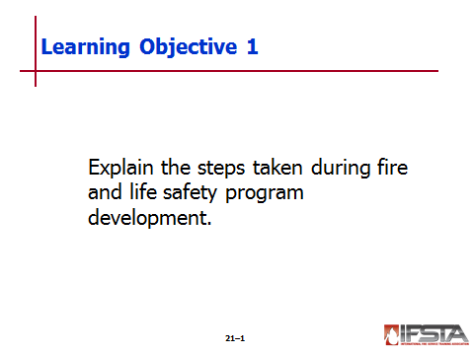
pp. 1222-1224 Objective 1 — Explain the steps taken during fire and life safety program development.
Instructor Note: Discuss the Information Box “National Support for Fire and Life Safety Initiative Programs” on p. 1222 of the manual. This information will help students begin to identify how fire and life safety programs can be developed and regulated.

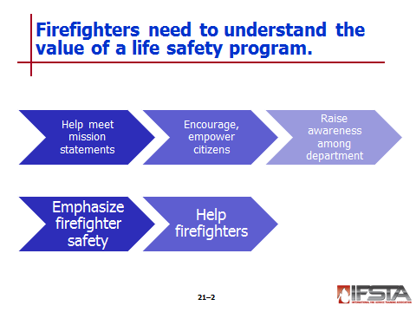
Program Value and Development – Must understand to perform duties

Value

Help meet fire department mission statements

Encourage, empower citizens in community to act in safe manner to reduce potential for fires, accidents, injuries

Raise awareness among department about possible hazards faced in community

Emphasize firefighter safety

Helps firefighters

Prepare for threats beyond control

Make plans to reduce potential injury, loss

Respond efficiently during post-incident period

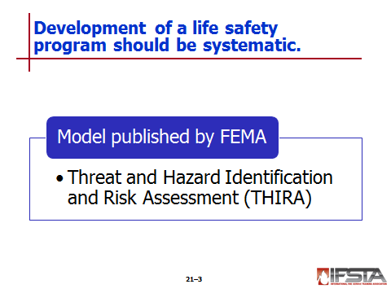
Development – Should be systematic

Guide published by Federal Emergency Management Administration (FEMA) can be used as model

Model known as Threat and Hazard Identification and Risk Assessment (THIRA) – Five step process to develop and implement program

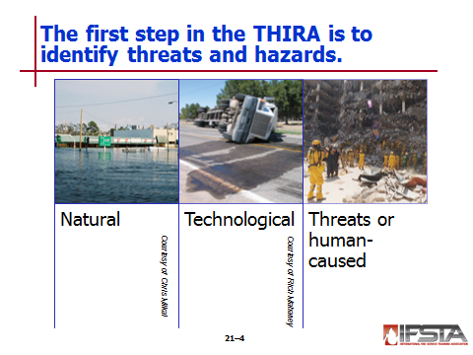
Identify Threats and Hazards

Required of community

Determine specific types of hazards will face

Determine threat hazard will pose

Estimate portion of population that may be affected

Performed through review of

Historical data

Trends

Statistical analysis

Threats divided into categories based on cause

Natural hazards

Acts of nature (hurricanes, earthquakes, tornadoes)

Disease outbreaks or epidemics

Technological hazards – Accidents or failures of systems and structures (hazardous materials spills or dam failures)

Threats or human-caused hazards – Intentional actions of adversary (threatened or actual chemical, biological, or cyber attack)

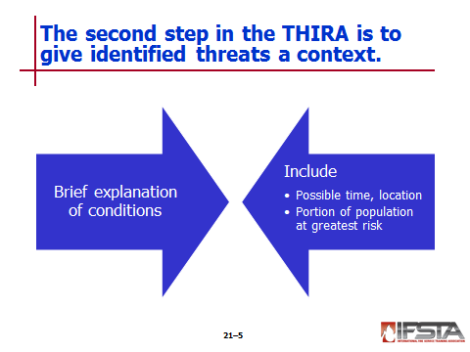
Give the Threats Context

Develop brief explanation of conditions under which threat or hazard might occur

Include

Possible time, location

Portion of population at greatest risk

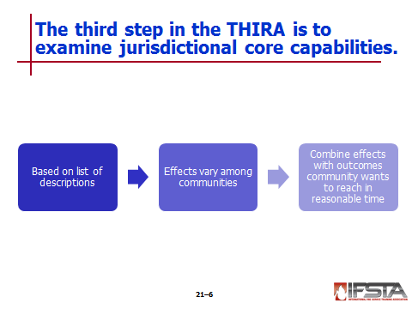
Examine Core Capabilities

Based on list of descriptions – Determine effect each threat and hazard will have on community

Effects vary among communities – Should include considerations

Displaced persons

Mass casualties

Devastation of property

Long-term loss of electrical service

Direct economic effects

Indirect economic effects

Disruption of supply system

Disruption to infrastructure

Combine effects with outcomes community wants to reach within reasonable time

Assessment of local response capabilities needed to determine if outcomes can be met

If local resources not sufficient, contingency plans need to be developed through

Mutual aid

Reliance on other governmental agencies

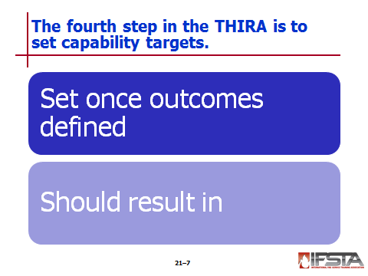
Set Capability Targets

Once outcomes defined – Set targets or goals

Should result in greatest benefit within desired time frame

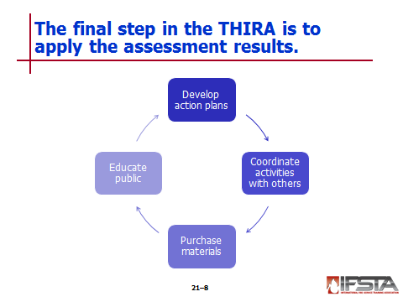
Apply Results

Use assessment results to

Develop action plans

Coordinate activities with other levels of government

Purchase materials

Educate public
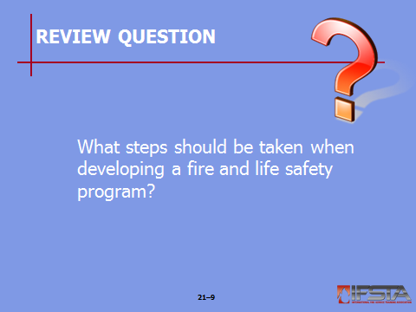
Review Question: What steps should be taken when developing a fire and life safety program?
See p. 1222 of the manual for answers.

Section II: Program Delivery

Program Delivery
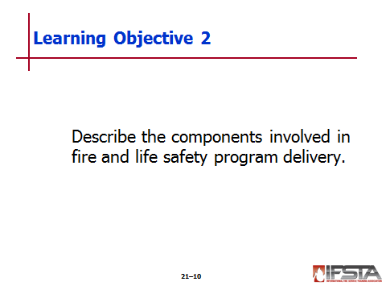
pp. 1224-1226 Objective 2 — Describe the components involved in fire and life safety program delivery.

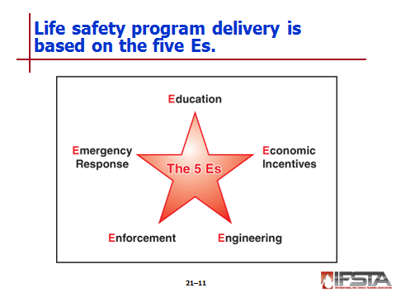
Education

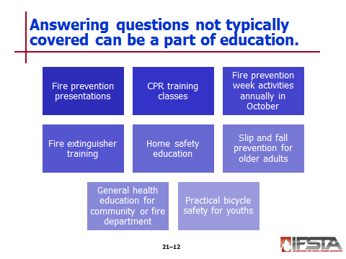
Must be able to answer questions on topics not traditionally covered under title of fire prevention

Public education programs can include

Fire prevention presentations

CPR training classes

Fire prevention week activities annually in October

Fire extinguisher training

Home safety education

Slip and fall prevention for older adults

General health education for community or fire department

Practical bicycle safety for youths

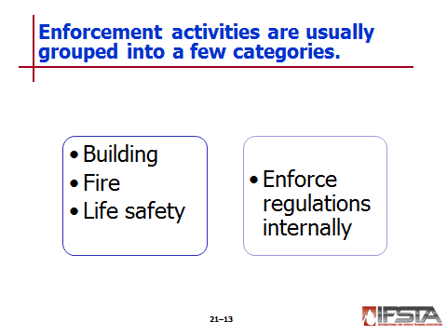
Enforcement

Activities usually limited to building, fire, life safety code enforcement

Perform periodic inspections of occupied properties to ensure structure meets locally adopted building and fire codes

Review, approve new construction and renovation plans

Investigate cause of fires

Document results

Provide law enforcement agencies with findings if reason to believe fire was intentional and illegal

Enforce regulations internally – Establish, adhere to departmental SOPs for operations

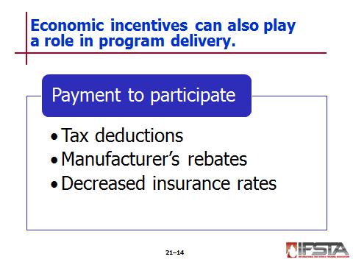
Economic Incentives

Pay individual for participating in program

Include

Tax deductions for installing sprinkler systems

Manufacturer’s rebates when smoke detector is purchased

Decreased insurance rates when community improves water distribution system

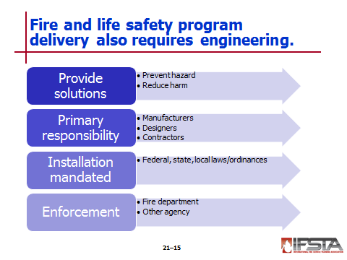
Engineering

Provides solutions to

Prevent hazard

Reduce harm once hazard occurs

Primarily responsibility of manufacturers, designers, contractors

Installation, use usually mandated by federal, state, local laws/ordinances

Enforcing local ordinances may be responsibility of fire department or other agency

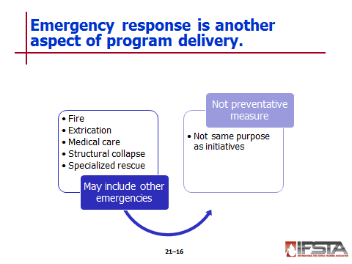
Emergency Response

Has expanded to include other types of emergencies

Fire response – Primary responsibility

May include extrication, medical care, structural collapse, specialized rescues

Not preventative measure – Does serve same purpose as initiatives program
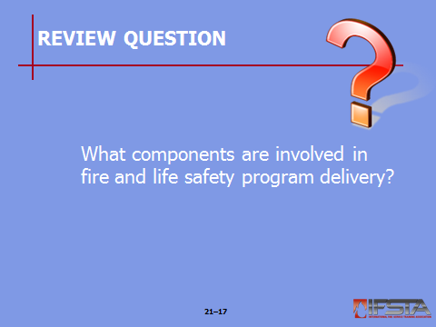
Review Question: What components are involved in fire and life safety program delivery?
See pp. 1224-1225 of the manual for answers.

Section III: Fire and Life Safety Education

Fire and life safety education
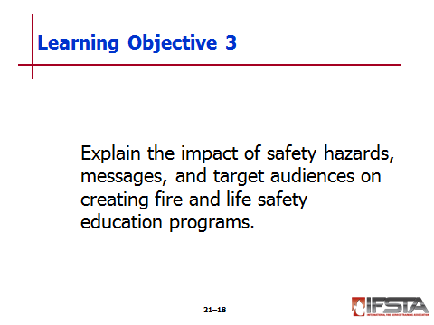
pp. 1226-1237 Objective 3 — Explain the impact of safety hazards, messages, and target audiences on creating fire and life safety education programs.
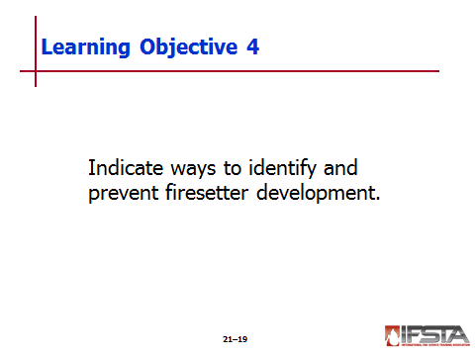
Objective 4 — Indicate ways to identify and prevent firesetter development.

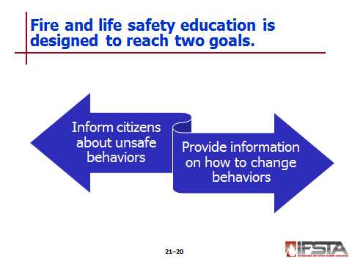
Fire and Life Safety Education

Designed to

Inform citizens about unsafe behaviors

Provide information on how to change behaviors

Can include formal or informal presentations

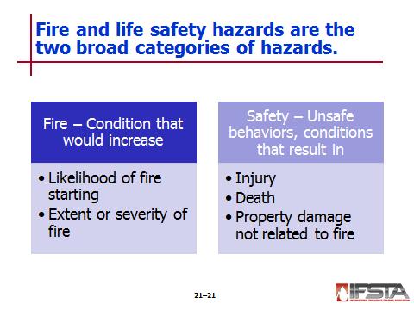
Fire and Life Safety Hazards

Broad categories

Fire hazard – Condition that would increase

Likelihood of fire starting

Extent or severity of fire

Safety hazard – Unsafe behaviors or conditions that result in injury, death, property damage not associated with fire

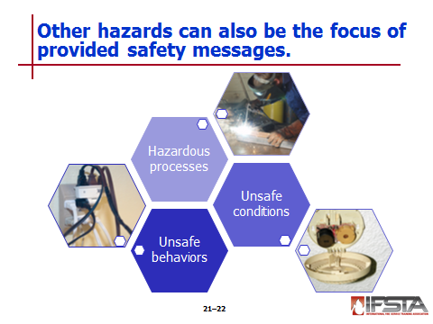
Unsafe behaviors

Activities that can cause fire or accidents leading to injuries or death

Usually corrected by educating people in consequences of actions, safest way to act

Be aware of following during preincident planning surveys, home safety surveys, following incidents

Poor housekeeping

Hoarding combustible materials

Ignoring ignition sources

Open burning

Improper use of electricity

Careless use of flammable and combustible liquids

Unsafe use of smoking materials

Unattended cooking materials

Unsafe behaviors not related to fire

Reckless operation of a motor vehicle

Not wearing safety belts

Texting while operating a motor vehicle

Speeding

Not wearing a safety helmet while riding a bicycle

Not holding onto a handrail while descending a stairway

Lifting or carrying an object that is too heavy or large for one person

Improper operation of a power tool

Removing or altering safe guards on power tools and equipment

Unsafe conditions

May

Arise from design or use of building, facility, or equipment

Be related to behaviors or process

Vary by occupancy

Result from mechanical failure or damage; environmental condition

Proper application of safety codes, standards help reduce sources; including

Electrical hazard conditions

Material storage facilities

Heating, ventilating, and air conditioning equipment/systems

Cooking equipment

Industrial furnaces and ovens

Loose handrail on a stairway

Ice on sidewalk or exterior stairs

Unsecured swimming pool access

Smoke detector – Dead battery in or nonworking

Hazardous processes

May exist temporarily or as constant function of industrial/manufacturing site

Ignition sources, hazardous atmospheres generated by

Welding

Cutting

Grinding

Painting

Dipping, quenching operations

Found in manufacturing facilities, auto repair and painting shops, fabrication businesses, furniture repair shops

Dry cleaning operations pose hazard based on types of chemicals used

Reduce hazards through

Enforcement of codes

Periodic inspections

Education

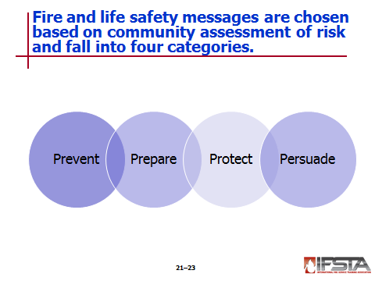
Fire and Life Safety Messages

Selected based on assessment of community’s risk

Fall into four categories

Prevent (Fire and Burns)

Prepare (For a Fire Emergency)

Protect (Yourself in an Emergency)

Persuade (Others to be Fire Safe)
Instructor Note: Discuss the fire and life safety message topics found on pp. 1228-1231 of the manual. Ask students what types of messages they would consider important for their local communities.
Answers will vary; be sure to emphasize that these messages should be based on the local needs of a community and will require firefighters to be aware of the types of hazards present in their communities.

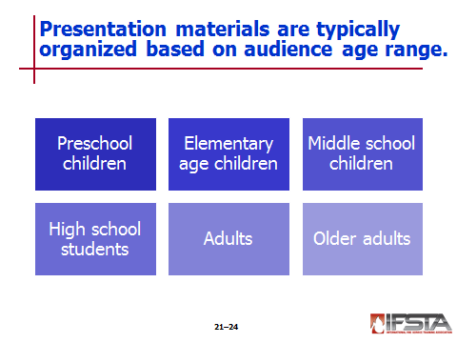
Fire and Life Safety Audiences – Materials usually organized based on age range of intended audience

Preschool children

Three- to five-year olds

Youngest group to whom messages can effectively be taught

Learn by seeing and doing

Seeing lasts longer than what they hear

Doing will last longer than what they see or hear

Appropriate messages

Match and lighter safety

Positively inform what to do when seeing – Do not focus on what not to do

Emphasis on telling adult when finding within reach – Must be told never to touch them

When clothes are on fire; Stop, Drop, and Roll

Often practiced, remembered

May be confused with what to do when house is on fire

Important to make distinction between two – Present at different times

Home escape

Do not understand cause/effect; do not perform well when making choices

Teach process in small segments – Put together behaviors as each is mastered

Process will take time

Firefighters as helpers

May fear protective clothing, breathing apparatus

Help eliminate fear by having children put equipment on firefighter one piece at a time

Bicycle helmets

Teaching helmet use at this time can create lifetime habit

Also present opportunities to discuss other bicycle riding safety rules

Poison prevention explaination

Most poisonings occur among children five years or younger

Emphasize dangers of taking medications, vitamins, other drugs without parent present; include look-alike products, drinks, foods
Instructor Note: Discuss what a look-alike product is and ways to help children understand how to avoid them. During the discussion emphasize that young children may not be able to grasp complex explainations.

Elementary age children

Messages similar to but more complex than those for preschool

Appropriate messages

Smoke alarm response – Can learn what they should do when activated

Survival skills – Taught correct actions to take at home in event of fire, tornado, earthquake, or other natural disaster

Use and misuse of fire – Taught responsible use of fire under supervision of adult; result of misuse of fire

Home escape plan – Create home fire escape plan

Middle school children

Are just beginning to take more adult responsibilities – May still have motivation of children

Appropriate messages

Burn care and prevention

Fire science – Making connection between fire behavior and classroom science

Health and safety education – CPR training

Cooking safety

Babysitting classes

Firesetting and other risky activities

Importance of home exit drills

High school students

Will respond to messages if information is believed to be relevant to them

Appropriate messages

Safe driving habits – Results that come from

Not wearing seat belts

Texting when driving

Inattentive driving

Using alcohol before or while driving

Smoke alarm safety – Need to learn how to

Maintain smoke alarms

Replace batteries

Install alarms

Respond to activated alarm

Fire service careers – Advantages of following career in fire service

Preparation for living independently – Information on

Cooking safety

Home security

Proper use of medication

Proper use of portable fire extinguishers

College fire safety – Hazards present in college dormitories, fraternity/sorority houses, apartments

Adults

Want practical programs applicable to professional or personal lives

Programs should involve

Solving problems

Completing tasks

Handling lifestyle choices

Common messages

Smoke alarms – Include information on installation, maintenance, testing, replacement

Residential sprinklers for new and existing construction – Be prepared to refute myths about residential sprinklers (especially concerning cost, performance)

Home escape plans and fire drills – Many families do not have home escape plan; may never have thought about creating fire drill

Disaster planning and preparedness for all ages – Important features

Developing disaster plan

Creating disaster supply kit

Establishing meeting places outside neighborhood

Overall unintentional injury prevention – Include fall prevention for older adults; accident prevention for children

Older adults

One of high-risk groups in community

Twice as likely to die from fire – Leading all other age groups

Greater risk for injuries due to fire, burn injuries; injuries related to trips, falls

Leading cause of fire fatalities – Smoking materials

Leading cause of injuries – Cooking fires

Appropriate messages

Safe cooking

Experience fires or burns due to unattended cooking

Due to diminishing sense of sight, smell, touch – Less likely to detect dangers

Careless smoking – Drowsiness, overmedication, combination of prescription medications and alcohol all contribute to greater risk for fires

Electrical appliances and equipment

May not understand dangers in using equipment or appliances that are old or in need of repair

May be reluctant to replace old items even though no longer safe to use

Falls

Common occurrence – Most take place inside home

May be caused by weakness, dizziness, diminishing vision, medications
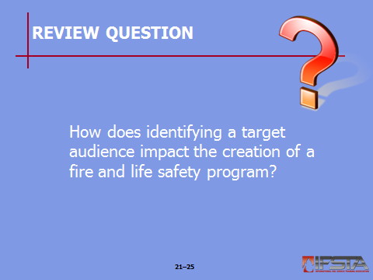
Review Question: How does identifying a target audience impact the creation of a fire and life safety program?
See pp. 1231-1235 of the manual for answers.

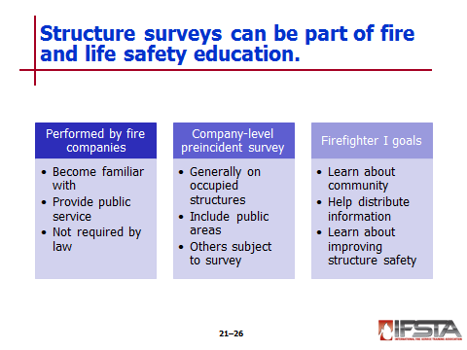
Structure Surveys as Part of Fire and Life Safety Education

Performed by fire companies

To become familiar with public-access structures, workplaces

Provide public service to homeowners, renters

Not required by law – Conducted on voluntary basis

Company-level preincident surveys

Generally conducted on occupied structures, not private residences

Include public (nonoccupant) areas of hotels, motels, apartment complexes

Also subject to survey are commercial, industrial, institutional, educational structures

Firefighter I goals during survey

Learn about community

Help distribute literature, information to community

Learn about improving structure safety alongside homeowners, business owners
NOTE: Information on conducting these surveys is provided in the Firefighter II section of this chapter.

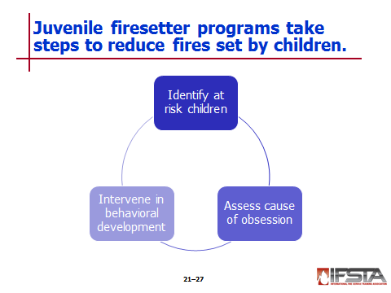
Juvenile Firesetters

Program intended to reduce fires set by children – Steps taken

Identify at-risk children

Assess cause of obsession

Intervene in behavioral development

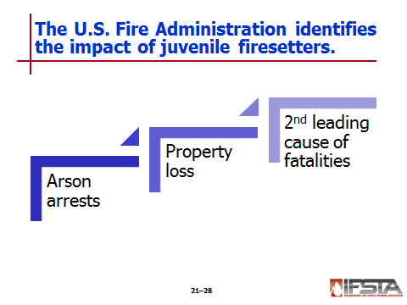
Impact of firesetters – Provided by U.S. Fire Administration (USFA)

Children under 18 years of age account for 54 percent of all arson arrests

Juvenile arson arrests proportionally higher than any other type of crime

Average property loss in fires set by juveniles in approximately 250,000 incidents exceeds $20,000

Is second leading cause of fatalities in residential fires

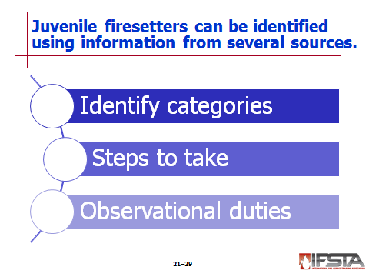
Identifying firesetters
Instructor Note: Discuss the four categories of juvenile firesetters explained in Table 21.2 on p. 1237 of the manual. Emphasize with the students the different characteristics of each type of juvenile firesetter category.

Specialists identify four categories

Curiosity/experimental

Troubled/crisis

Delinquent/criminal

Pathological/emotionally disturbed

Be aware of categories, indicators to help locate at-risk children

Steps to take

Include juvenile firesetter information in presentations, station tours

Look for indicators during fire cause determination

Be aware of actions of family, friends that may be indication of problem

Demonstrate fire safe behavior

Observational duties

Parents, teachers, neighbors may observe actions

Firefighters should watch for trends

Locations

Types of structures

Time of day

Discuss patterns with other personnel

Watch for familiar faces at fires

Gather information, follow department policy if information provided by outside parties

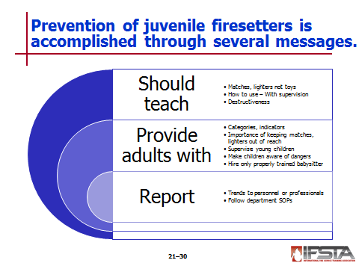
Preventing firesetter development

Program should teach

That matches, lighters are tools – Not toys

How to safely use fire under adult supervision

About destructiveness of fire when not properly used

Provide adults with program information – Such as

Categories of juvenile firesetters; indicators of each

Importance of keeping matches, lighters out of reach of small children

They must supervise young children; importance of never leaving them alone with open flames

Making children aware of dangers of fire when improperly used

Reasons only trained babysitters should be hired

Report trends to fire investigation personnel or juvenile firesetter intervention professional – Always follow department SOPs
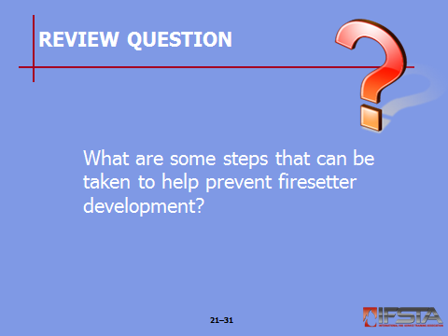
Review Question: What are some steps that can be taken to help prevent firesetter development?
See pp. 1236-1237 of the manual for answers.

Section IV: Fire and Life Safety Codes

Fire and life safety Codes
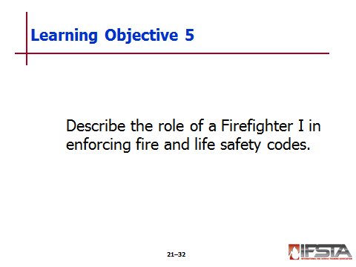
pp. 1237-1240 Objective 5 — Describe the role of a Firefighter I in enforcing fire and life safety codes.
Note: Refer to Chapter 1 for more information on codes and standards.

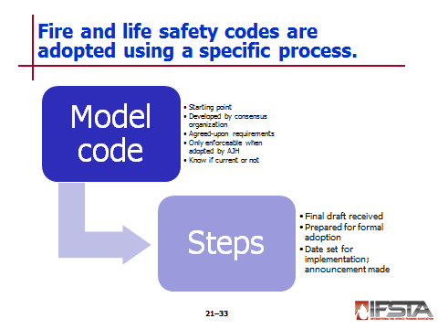
Code Adoption

Model code

Usually starting point for adoption process

Developed by consensus organization

Contains agreed-upon requirements for areas

Model code organizations

Canada – Canadian Commission on Building and Fire Codes (CCBFC)

United States – International Code Council® (ICC®); National Fire Protection Association® (NFPA®)

Instructor Note: Discuss the Information Box “Department of Defense (DoD)” found on p. 1238 of the manual. Ask students if there are any facilities in their jurisdictions that may be regulated under these model codes.
Answers will vary; emphasize with students that this is an issue that should be identified in preincident planning.

Codes only enforceable when AHJ adopts – Code may be

Adopted with no changes

Amended to meet local requirements

Created locally

Know whether codes, standards are current

Most revised on regular cycle – Typically 3 to 5 years

Revised edition does not automatically take effect until legally adopted

Steps taken

Final draft of proposed model code received

Prepared for legislative resolution for formal adoption

Once adopted – Date set for implementation; public announcement made

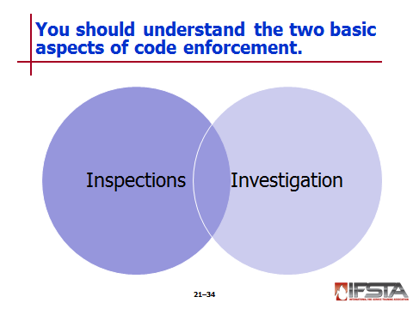
Code Enforcement

Inspections

Inspectors trained in code interpretation monitor construction, renovation process

May be involved in plan review, construction inspections

Make periodic inspections used to ensure structure is in compliance

Be aware of code requirements

If made aware of potential life-threatening conditions – Follow local SOPs to report to local inspections office

Investigation

Provide data about types, causes of fires in community

Can be used to develop, monitor effectiveness of safety initiative program

Law enforcement tools that attempt to determine responsibility for intentionally set fires

Help make products, processes, materials safer

Firefighters, supervisors – May be involved in initial portion of cause determination

When working with fire investigator

May be necessary to request assistance of other personnel

Work to locate, protect evidence; gather information; provide impression of events

Use situational awareness to provide accurate information
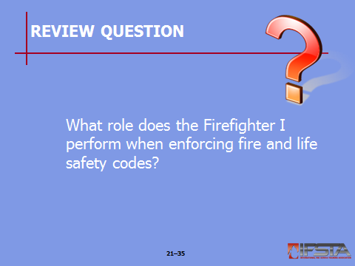
Review Question: What role does the Firefighter I perform when enforcing fire and life safety codes?
See pp. 1239-1240 of the manual for answers.

Section V: Summary and Review

V. SUMMARY AND REVIEW

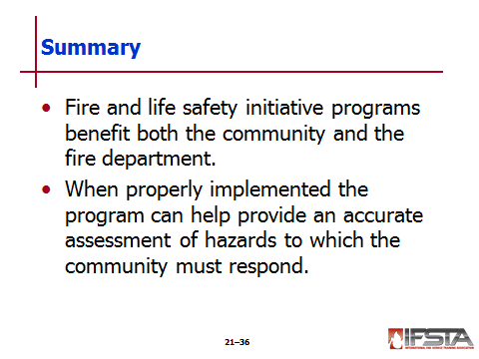
Chapter Summary

Fire and life safety initiative programs benefit both the community and the fire department.

When properly implemented the program can help provide an accurate assessment of hazards to which the community must respond.

Review Questions

What steps should be taken when developing a fire and life safety program? (1222)

What components are involved in fire and life safety program delivery? (1224-1225)

How does identifying a target audience impact the creation of a fire and life safety program? (1231-1235)

What are some steps that can be taken to help prevent firesetter development? (1236-1237)

What role does the Firefighter I perform when enforcing fire and life safety codes? (1239-1240)

