Chapter 17
Fire Control

Lesson Goal
After completing this lesson, the student shall be able to describe tasks related to coordinating fireground operations, establishing command, and controlling Class B fires.
Objectives
Upon successful completion of this lesson, the student shall be able to:
1. Describe considerations taken when coordinating fireground operations. [NFPA® 1001, 6.1.1, 6.1.2, 6.3.2]
2. Explain fireground roles and responsibilities a firefighter II may need to coordinate. [NFPA® 1001, 6.1.1, 6.1.2, 6.3.2]
3. Discuss the process of establishing and transferring Command. [NFPA® 1001, 6.1.1, 6.1.2, 6.3.2]
4. Describe hazards that may be present at fires in underground spaces. [NFPA® 1001, 6.3.2]
5. List safety precautions that should be taken at flammable/combustible liquid fire incidents. [NFPA® 1001, 6.3.1, 6.3.3]
6. Recognize methods used when coordinating operations at a property protected by a fire suppression system. [NFPA® 1001, 6.3.2]
7. Explain ways to use water to control Class B fires. [NFPA® 1001, 6.3.1]
8. Compare methods used to suppress bulk transport vehicle fires and flammable gas incidents. [NFPA® 1001, 6.3.3]
9. Establish Incident Command and coordinate interior attack of a structure fire. [NFPA® 1001, 6.1.1, 6.1.2, 6.3.2; Skill Sheet 17-II-1]
10. Control a pressurized flammable gas container fire. [NFPA® 1001, 6.3.3; Skill Sheet 17-II-2]

Instructor Information
This is the lesson covering coordinating fireground operations and the process of establishing and transferring Command. This lesson describes methods used when operating with fixed suppression systems. The lesson also covers attack considerations for flammable/combustible liquid and Class B fires.

Important instructor information is provided in shaded boxes throughout the lesson plan. Carefully review the instructor information before presenting the lesson.

This lesson includes skill evaluation checklist(s) that assess student ability to perform skills related to establishing Command and controlling a pressurized gas container fire This checklist(s) will allow students to meet the requirements of learning objectives 9-10.

Methodology
This lesson uses lecture, discussion, and skills practice. The level of learning is application.
Table of Contents
Section | Lesson Plan | Text
Section I: Coordinating Fireground Operations | 6 | 1057
Section II: Suppressing Class B Fires | 23 | 1068
Section III: Skill Sheets | 41 | 1098
Section IV: Summary and Review | 42 | 1076

Audiovisuals/Handouts
- Visuals 17.1 to 17.54 (PowerPoint® Presentation)

Evaluation
- Chapter 17 Quiz
- Chapter 17 Test
- Skill Evaluation Checklists 17-II-1 to 17-II-2

Instructor Tools
Interactive Objects allow instructors to present information a piece at a time by clicking on hot spots in a larger image.

Each object is labeled in the Lesson Outline and indicated in the Power Point presentation by a RED arrow in the top left corner of the image. This lets instructors know to use the mouse to explore all of the information on the slide.


After all of the information is displayed a reset arrow will appear in the bottom right corner of the image. Instructors can use this to remove the text and quiz students on content just covered or simply move on to the next slide.

To move to the slide after an interactive object, select the Click for next slide arrow on the left side of the slide.

Videos are used as discussion starters or to illustrate a concept or process discussed in the chapter.

These are labeled in the Lesson Outline and indicated in the Power Point presentation by the Click image to play arrow on the left side of the slide.
Section I: Coordinating Fireground Operations

Coordinating fireground operations
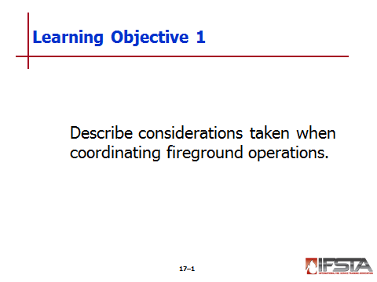
pp. 1057-1058 Objective 1 — Describe considerations taken when coordinating fireground operations.

Coordinating Fireground Operations

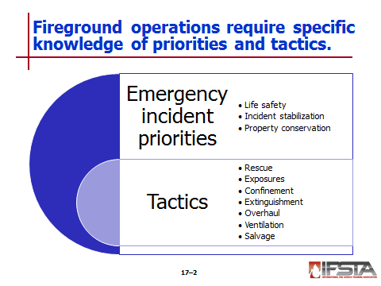
Emergency incident priorities

Life safety

Incident stabilization

Property conservation

Apply following tactics to achieve

Rescue

Exposures

Confinement

Extinguishment

Overhaul

Ventilation

Salvage

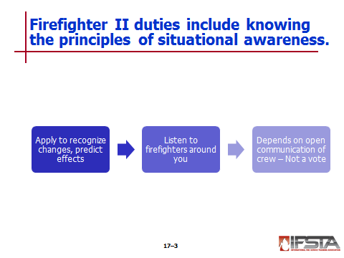
Situational Awareness

Firefighter II duties

Apply situational awareness

Responsible for safety of firefighters assigned to you

Use additional training to recognize changes, predict effects on surroundings

Listen to concerns, observations of firefighters with you – They may

See something you overlooked or have additional information

Have different physical point of view, be able to see something you cannot

Depends on open communication of all members of crew; allows leader to make informed decisions

Is not meant as opportunity for debate, vote

Crew leader has final authority – Gather information, make a decision based on input
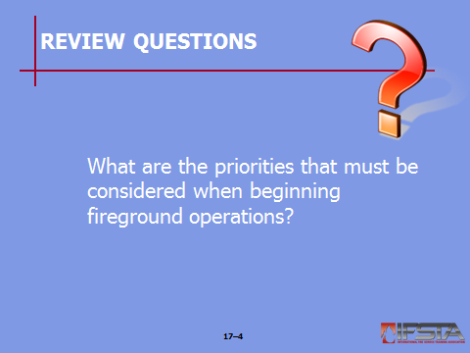
Review Question: What are the priorities that must be considered when beginning fireground operations?
See pages 1057-1058 of the manual for answers.
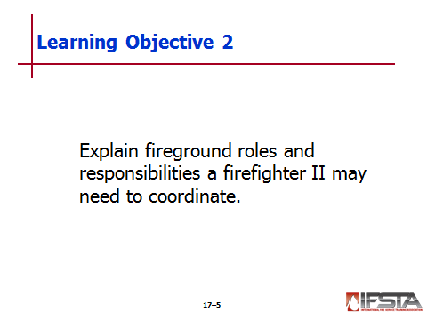
pp. 1058-1060 Objective 2 — Explain fireground roles and responsibilities a firefighter II may need to coordinate.

First-Arriving Engine Company

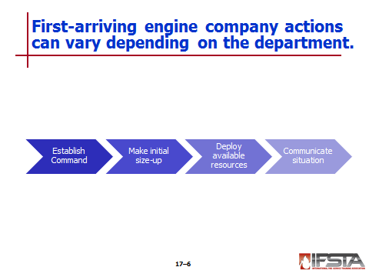
Department SOPs define actions – Typically include

Establish Command

Make the initial size-up

Deploy available resources

Communicate situation to communication center, other responding units
NOTE: Establishing Command is described in more detail later in this chapter.

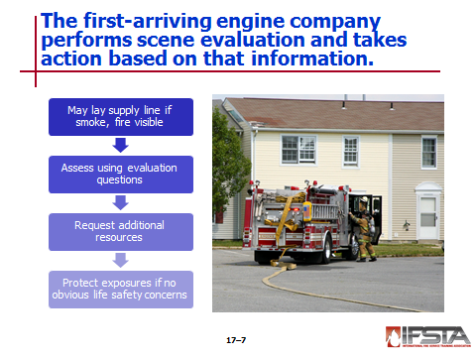
Other possible SOP defined duties

If smoke, fire visible

May lay supply line from closest hydrant to fire

Hydrant can be opened, supply line charged as soon as hose clamp applied at scene

May have option to deploy supply line or proceed directly to scene, initiating quick attack with apparatus water supply

Perform quick evaluation based on certain questions

Are there occupants in need of immediate rescue?

Does fire threaten other exposures?

What does visible fire, smoke indicate?

Are only contents involved or is structure burning?

Are there sufficient resources on scene or en route to handle situation?

Request additional resources to meet incident objectives established during size-up if needed

Must be able to adhere to two-in, two-out rule

No one enters until enough personnel present to conform to rule

Rule may be amended

Two-person attack team, one person outside

Only if known life safety hazard to victim that can be saved without undue risk to firefighters

If not obvious, immediate life safety concerns and fire is threatening nearby exposure

May order hoselines deployed to apply water

Master stream or handline may cool exposure while hoselines deployed for direct attack

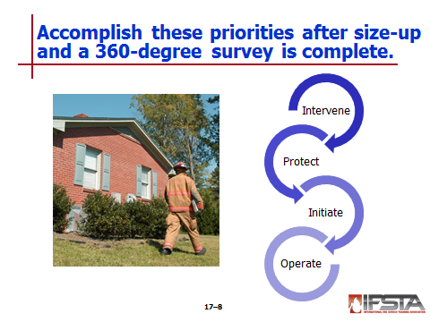
After size-up, 360-degree survey complete; location of fire known – Accomplish priorities

Intervene between trapped occupants and fire

Protect rescuers

Protect primary means of egress

Protect interior exposures (other rooms)

Protect exterior exposures (other buildings)

Initiate extinguishment

Operate master streams

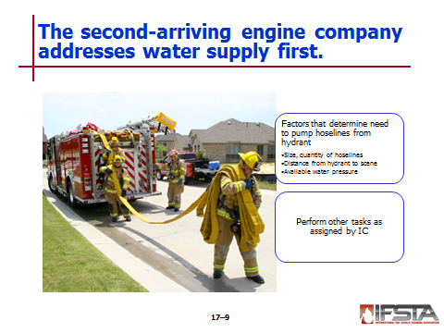
Second-Arriving Engine Company

First – Make sure adequate water supply established to fireground

May complete tasks begun by first engine company

Finishing hose lay

Deploying additional hoseline

Connecting to hydrant to support hoselines already deployed

Local factors that determine need to pump hoselines from hydrant

Size and quantity of hoselines

Distance from fire hydrant to scene

Available water pressure in distribution system

Once water supply established – Perform tasks as assigned by IC

Assist advancing first attack hoseline

Back up initial attack line

Protect secondary means of egress

Prevent fire extension (confinement)

Protect most threatened exposure

Assist in extinguishment

Assist with fireground support company operations

Form rapid intervention crew/team (RIC/RIT)

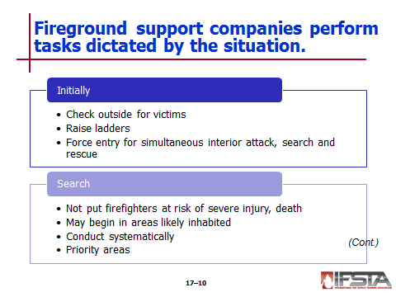
Fireground Support Company

If dispatched – May arrive before, with, after first engine

Situation will dictate tasks performed
Instructor Note: Discuss the possible support company tasks listed on p. 1061 of the manual. Ask students what types of support companies exist in their jurisdictions. Answers will vary, be sure to emphasize that the tasks performed by these companies will be determined by local SOPs.

May be performed by engine company if support company not available

Initially may be assigned to

Check outside of building for victims needing immediate rescue

Raise ladders needed for rescuers, roof access for ventilation

Force entry into building for simultaneous interior fire attack, search and rescue operations

Search

Area closest to fire if it will not put firefighters at risk of severe injury, death

Patterns may begin in areas most likely inhabited, where known victims are trapped

Must be conducted systematically, in accordance with SOPs

Priority areas

Most severely threatened – If searchable without undue risk to firefighter safety

Where largest number are threatened – If area is searchable without undue risk to firefighter safety

Remainder of fire area

Exposures

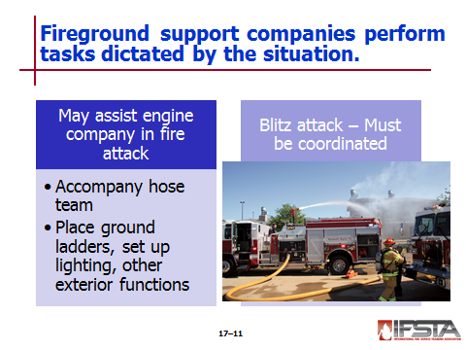
May assist engine company in fire attack – Depends on SOPs

Accompany hose team advancing toward seat of fire when equipped with forcible entry tools

May place ground ladders, set up scene lighting, or similar exterior functions

Blitz attack – May be performed with master stream device, aerial ladders, platforms, ladder towers

Must be coordinated with other operations to avoid fire spread

Steam can injure interior teams – Poorly directed streams can force retreat

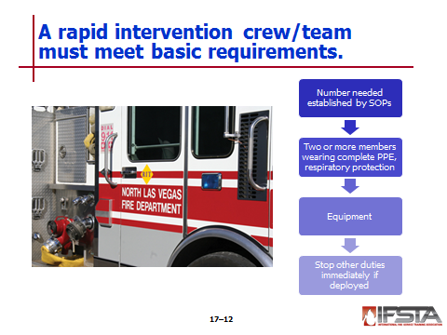
Rapid Intervention Crew/Team (RIC/RIT)

Basic description, requirements

Locate, assist firefighters trapped, lost, or incapacitated during operations

May be any engine, ladder, rescue company equipped and assigned when arriving on scene – May be permanently designated

Number needed established by SOPs or IC – Crews added as necessary

Team operations

Defined as – Two or more members wearing complete PPE, respiratory protection

Be equipped with

Radio

Special rescue tools needed

Spare SCBA or air cylinder

Equipment needed to perform rescue

May be assigned other minor scene duties – Must stop immediately, deploy if needed

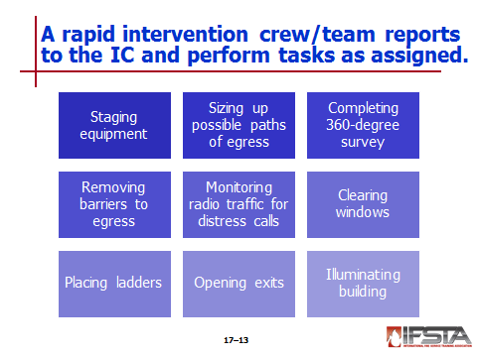
Report to IC and perform several tasks

Staging equipment

Sizing up building for possible paths of egress

Completing 360-degree survey if possible

Removing barriers to egress

Monitoring radio traffic for distress calls

Clearing windows

Placing ladders

Opening exits

Illuminating building
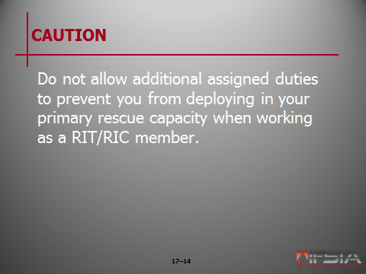
Caution: Do not allow additional assigned duties to prevent you from deploying in your primary rescue capacity when working as a RIT/RIC member.

Chief Officer/Incident Commander

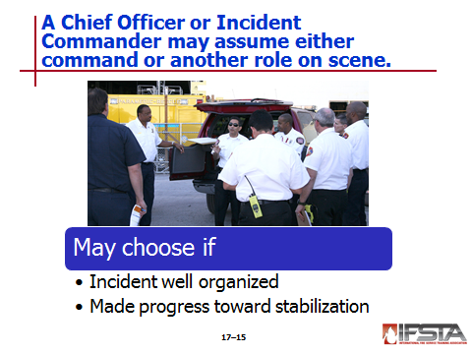
Chief officer may assume command from original IC – Take responsibility for all on-scene operations

May choose to assume other role if original IC has

Incident well organized

Made reasonable progress toward incident stabilization
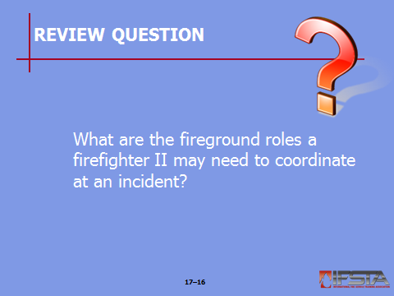
Review Question: What are the fire ground roles a firefighter II may need to coordinate at an incident?
See pages 1058-1063 of the manual for answers.
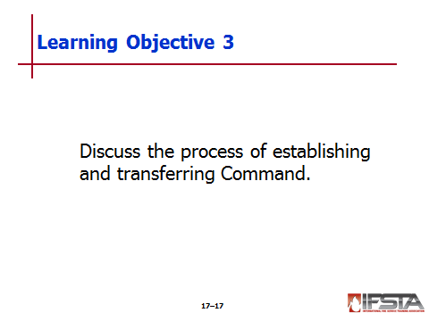
pp. 1064-1068 Objective 3 — Discuss the process of establishing and transferring Command.
Objective 4 — Describe hazards that may be present at fires in underground spaces.
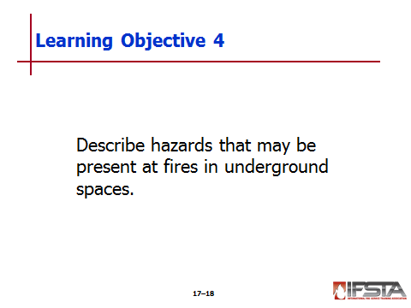
Instructor Note: This information correlates with Skill Sheet 17-II-1. More information is found at the end of this lesson outline.

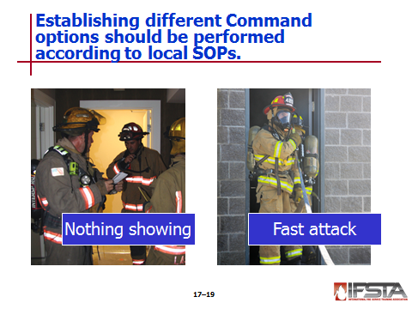
Establishing Command – Follow local SOPs to relay initial Command options

Nothing showing – Problem is not obvious to first-arriving unit

Assume Command – Broadcast “nothing is showing”

Direct other responding units to

Assume predetermined positions at scene or stage at last intersection in route of travel

Allows for maximum deployment flexibility – Applies to all types of emergencies

Accompany unit personnel on investigation of situation

Maintain command using portable radio

Known as investigation mode

Fast-attack – Necessary to take immediate action to save life, or stabilize situation

Take Command – Announce unit is initiating fast attack

Personnel continue fast attack until

Incident is stabilized

Incident is not stabilized – Must withdraw outside hazardous area to establish formal Incident Command Post (ICP)

Command is transferred

Balance of unit may be left inside hazardous area

If they can function safely and have radio communications

No fewer than two may be left – If officer/firefighter must leave, both must leave

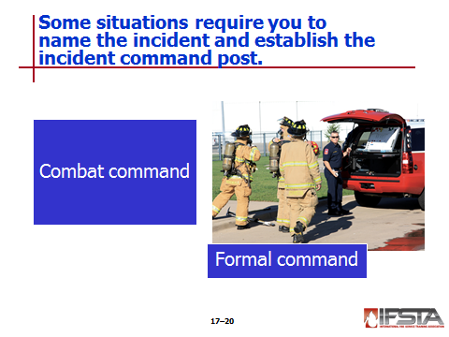
Name the incident and establish the ICP – Based on nature, scope of incident

Assume Command by

Naming incident

Designating ICP

Giving initial report on conditions

Requesting additional resources

Types of incidents that may require

Combat command – Officer/firefighter performs

Multiple tasks – Serves as Incident Commander (IC), develops incident action plan (IAP)

Active tasks – Advancing hoseline

Formal command – Company officer remains at mobile radio in the apparatus

Assigns tasks to unit personnel

Communicates with other responding units

Expands NIMS-ICS as needed

Must decide how to deploy remainder of the unit

Three options
Instructor Note: Discuss the possible deployment options listed on p. 1064-1065 of the manual. Ask students how to best determine when each option might be the best choice. Answers will vary, be sure to emphasize that these choices will be influenced by local SOPs and conditions at each situation.

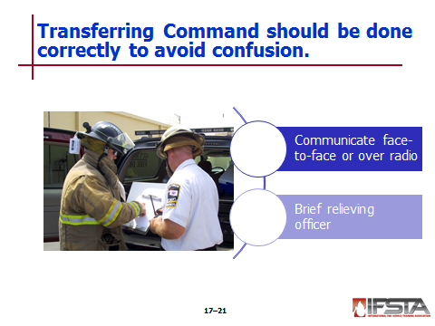
Transferring Command – Must be done correctly to avoid confusion

Communicate either face-to-face or over radio with officer/firefighter being relieved

Face-to-face preferred

Command should never be transferred to anyone not on scene

Brief relieving officer on

Name of incident

Incident status

Safety considerations

Goals and objectives listed in IAP

Progress toward completion of tactical objectives

Deployment of assigned resources

Assessment of need for additional resources
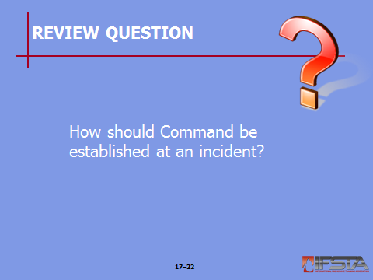
Review Question: How should Command be established at an incident?
See pages 1064-1066 of the manual for answers.

Fires in Underground Spaces
Instructor Note: Discuss the types of underground spaces listed on p. 1066 of the manual. Ask students which of these exist in their local jurisdictions. Answers will vary, be sure to ask students to include mutual aid locations when considering possible spaces.

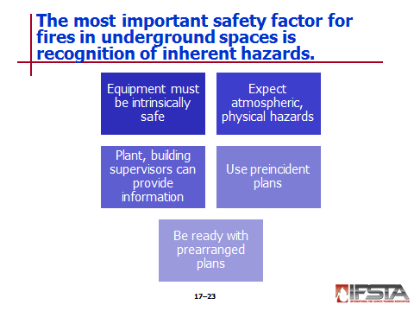
Most important safety factor – Recognition of inherent hazards

Electrical equipment should be intrinsically safe for use in flammable atmospheres

Expect atmospheric, physical hazards

Oxygen deficiencies

Flammable gases and vapors

Toxic gases

Extreme temperatures

Explosive dusts

Limited means of entry and egress

Cave-ins or unstable support members

Standing water or other liquids

Utility hazards – Electricity, gas, sewage

Plant, building supervisors or other knowledgeable people can provide information on

Fire

Probable location

Hazards present

Preincident plans reduce guesswork – Refer to during operations

Be ready to implement prearranged hazard mitigation plans, rescues, extinguishment efforts without delay

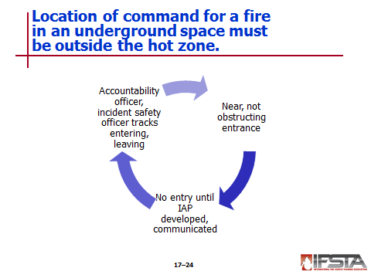
Command Post, staging area must be established outside hot zone

Staging near, not obstructing, entrance

Do not allow entry until IAP developed, communicated to on-scene personnel

Accountability officer or incident safety officer at entrance to track personnel, equipment entering and leaving

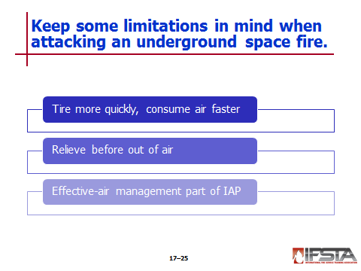
May attack indirectly using penetrating, cellar, or distributor nozzles

May tire more quickly, consume air faster due to difficulty venting heat from space

Relieve before out of air

Effective air-management should be part of IAP to prevent advancing farther than air supplies safely allow
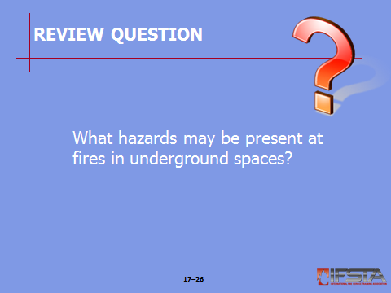
Review Question: What hazards may be present at fires in underground spaces?
See pages 1066-1068 of the manual for answers.

Section II: Suppressing Class B Fires

Suppressing Class B Fires
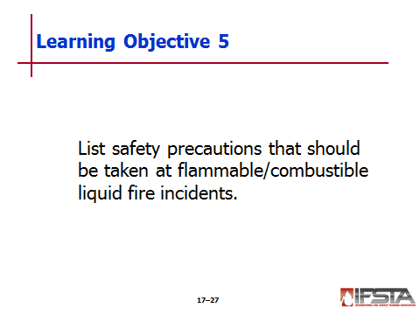
pp. 1068 Objective 5 — List safety precautions that should be taken at flammable/combustible liquid fire incidents.
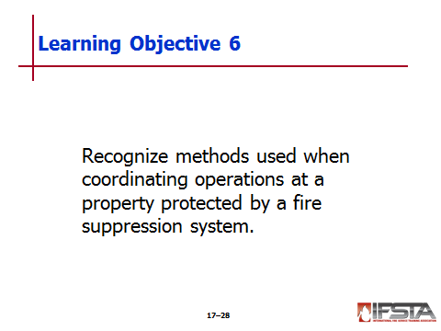
Objective 6 — Recognize methods used when coordinating operations at a property protected by a fire suppression system.

Suppressing Class B Fires

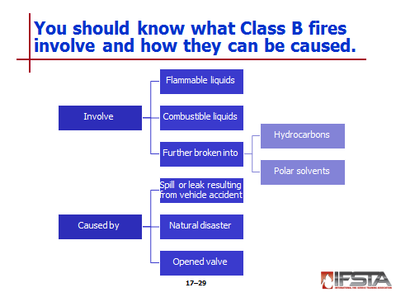
Involve flammable, combustible liquids and gases

Flammable liquids

Flash point of less than 100°F (38°C)

Can be ignited without being preheated

Examples – Gasoline, acetone

Combustible liquids

Flash point higher than 100°F (38°C)

Must be heated above flash point before igniting

Examples – Kerosene, vegetable oil

Both further divided into

Hydrocarbons – Do not mix with water

Polar solvents – Do mix with water

Class B fires may be caused by

Spill or leak resulting from vehicle accident

Natural disaster

Opened valve

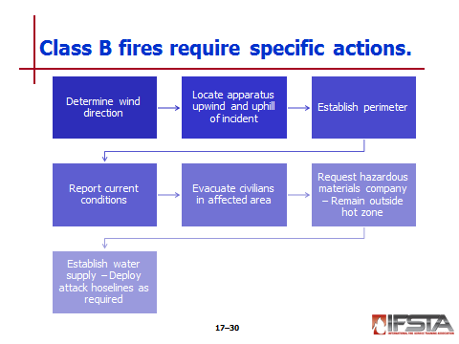
Actions to take

First action – Determine wind direction; current can spread vapors or gases

Locate apparatus upwind and uphill of incident

Establish perimeter

Report current conditions to all responding units, communications center

Evacuate any civilians in affected area

Request hazardous materials response company; remain outside hot zone

Establish water supply; deploy attack hoselines as required

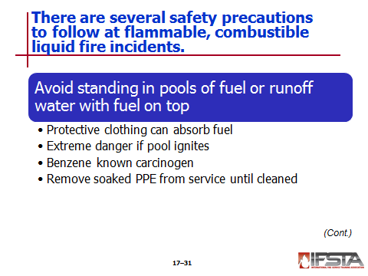
Safety Precautions at Flammable/Combustible Liquid Fire Incidents

Avoid standing in pools of fuel or runoff water contaminated with fuel floating on top

Protective clothing can absorb fuel in wicking action

Can lead to skin irritation

Clothing may catch on fire if ignition source present

Extreme danger exists if pool ignites

Benzene in petroleum product fumes is known carcinogen

Remove PPE soaked with flammable, combustible liquids from service until cleaned according to manufacturer’s recommendations
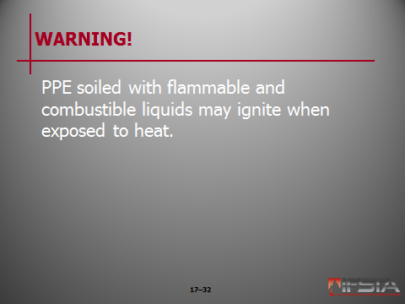
WARNING!: PPE soiled with flammable and combustible liquids may ignite when exposed to heat.

Do not extinguish liquids burning around relief valves or piping until leak is controlled

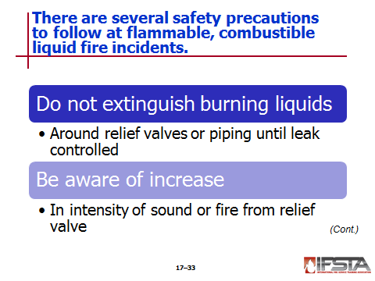
Unburned vapors heavier than air

Form pools or pockets of gas in low areas

May ignite

Attempt to control all ignition sources in leak area

Vehicles

Smoking materials

Electrical fixtures

Sparks from tools

Be aware of increase in intensity of sound or fire from relief valve

May indicate vessel is overheating, rupture imminent

Do not assume valve sufficient to safely relieve excess pressures under severe conditions

Rupture can cause fatalities

Recognize conditions created when liquid is heated in closed container

Liquid expands – Change from liquid to gas increases internal pressure of vessel

When too much pressure builds – Vessel loses structural integrity, ruptures

Rupture releases massive amounts of pressure, flammable contents of vessel – Can result in BLEVE

Liquid or liquefied gas must be above its boiling point (at standard temperature, pressure) when container fails

BLEVE produces

Violent explosion that sends large pieces of tank flying in all directions

Huge fireball with radiant heat sufficient to incinerate anything near site

Tank failure may be result of

Mechanical damage to tank

Direct flame impingement on vapor space in tank

Most common cause when

Flames contact shell above liquid level

Insufficient water applied to keep tank shell cool

To attack fire

Apply water to upper portions of tank

Preferably applied from unattended master stream devices

Method most often used to control flammable liquid fires – Apply foam
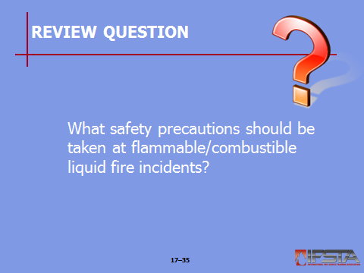
Review Question: What safety precautions should be taken at flammable/combustible liquid fire incidents?
See pages 1069-1070 of the manual for answers.

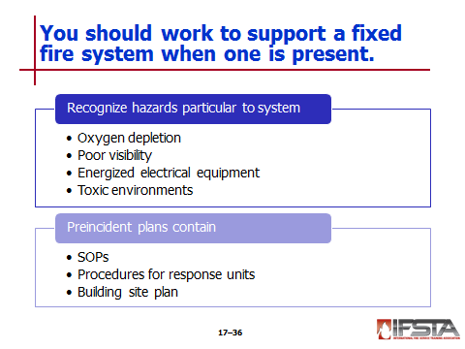
Fires in Properties Protected by Fixed Systems

Work to support system – Not work against it

Recognize hazards particular to system

Oxygen depletion following activation of carbon dioxide flooding systems

Poor visibility

Energized electrical equipment

Toxic environments

Preincident plans contain

SOPs used at occupancies

Procedures for each response unit to follow according to conditions found

Building site plan

Shows water supplies, protection system connections, unit placement

Must be updated regularly

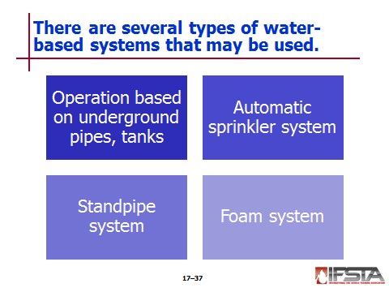
Water-based systems

Operation

Depend on water from underground pipes or water storage tanks

Supplement water or maintain operating pressure by deploying supply hoses from hydrant to fire department connection (FDC)

Automatic sprinkler system – Personnel manage system following local SOPs to take action

Connect pumper to FDC to supplement water supply; maintain constant pressure on system

Assign radio-equipped firefighter to sprinkler control valve to close or reopen as ordered, prevent it from being closed prematurely

Install wooden wedges or sprinkler stops to halt flow of water from open sprinklers

Replace open sprinklers to allow system to be restored to normal

Restore sprinkler system to normal

Monitor building after fire has been extinguished while waiting for owner or designee to restore sprinkler system

Standpipe systems – Allow deployment of attack hoselines on upper stories of structures, in large area structures or industrial sites

Pumpers connect supply hoses to standpipe connection, increase system pressure based on amount of friction loss

High-rise structures may have pumps installed on upper stories to help maintain pressure

Tasks to perform when coordinating fire attack

Connect pumper to FDC to supplement water supply, maintain constant pressure on system

Determine location of fire

Don full PPE, respiratory protection

Take necessary tools, hose, nozzle, equipment to standpipe outlet located in stairwell below fire floor

Connect attack hoseline to outlet, advance line up stairs to door into fire floor

Charge hoseline, bleed air off line, adjust nozzle for desired pattern

Advance hoseline onto fire floor, use appropriate attack method to extinguish fire

Foam systems – Installed where large quantities of Class B flammable/combustible liquids stored, used

May include connections to FDCs or may be self-contained

Critical that foam blanket not be disturbed when activated

More of same type of foam can be added to layer

Locations may have total flooding system installed – Entire compartment, structure filled with foam

Do not disturb foam, allow to remain in place until complete extinguishment determined

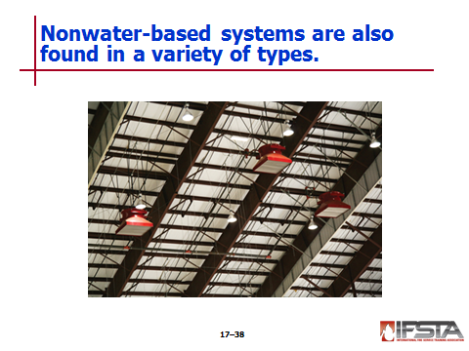
Nonwater-based systems

Found in

Industrial occupancies

Aircraft hangers, maintenance facilities

Large cargo vessels

Include

Carbon dioxide

Clean agent

Dry-, wet- chemical systems

When active will either

Fill compartment with extinguishing agent (carbon dioxide, clean agent)

Blanket fire (dry-, wet-chemical)

Do not disturb or remove agent until complete extinguishment determined

Deploy, position attack hoselines to prevent fires in adjacent Class A materials

Wear SCBA when entering, working in areas where agents have been used
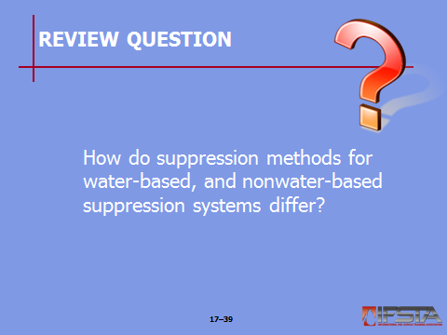
Review Question: How do suppression methods for water-based, and nonwater-based suppression systems differ?
See pages 1071-1072 of the manual for answers.
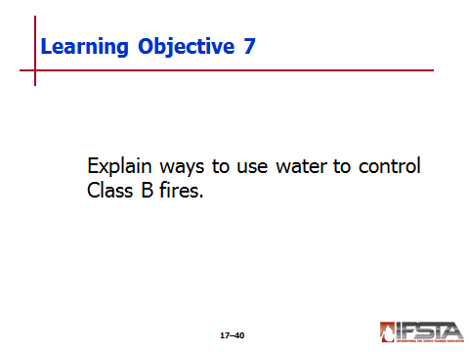
pp. 1073 Objective 7 — Explain ways to use water to control Class B fires.
Objective 8 — Compare methods used to suppress bulk transport vehicle fires and flammable gas incidents.

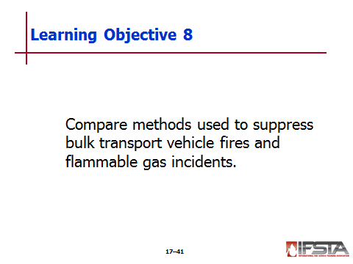
Using Water to Control Class B Fires

Ineffective agent when used alone

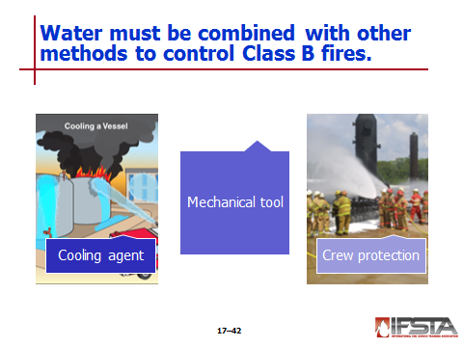
Must remember

Hydrocarbons do not mix with water

Polar solvents do mix with water

Cooling agent

Without foam additives not effective on lighter petroleum distillates or alcohols

Can absorb heat in heavier oils, extinguish fire when applied as droplets in sufficient quantities

Most useful for protecting exposures

Streams must be applied to form protective water film on materials that may weaken or collapse

Should be applied above level of contained liquid on burning storage tanks

Mechanical tool

Can be used to move Class B fuels to areas where they can safely burn or be more easily controlled

NEVER flush down storm drains, into sewers

Use appropriate fog patterns

For protection from radiant heat

To prevent plunging stream into liquid

Causes increased production of flammable vapors

Greatly increases fire intensity

Slowly move stream from side to side, sweep fuel or fire to desired location

Keep leading edge of fog pattern in contact with fuel surface – Fire may flash under stream back toward crew

Fog stream may be used to dissipate flammable vapors

Crew protection

Fog stream patterns used when advancing to shut off liquid or gas control valves

One hoseline can be used for crew protection, two lines with back up line preferred
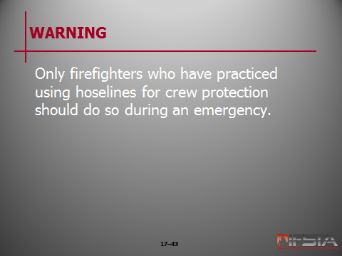
WARNING!: Only firefighters who have practiced using hoselines for crew protection should do so during an emergency.

When pressure vessels exposed to flame impingement

Apply solid streams from maximum effective reach until relief valves close

Minimum of 500 gpm (1 900 L/min) must be applied at each point of flame impingement

Arch stream along top of vessel until water runs down on both sides

Cools vapor space inside tank, tank shell, steel supports under tank

Supports cooled to prevent collapse

No safe angle to approach fire-involved pressurized storage tank – Rupture causes metal fragments in all directions

If necessary to make temporary repairs, shut off fuel source

Use hoseline advance to tank on fire using wide protective fog pattern

Use separate pump, water source to supply backup hoseline
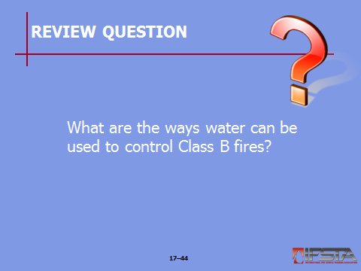
Review Question: What are the ways water can be used to control Class B fires?
See pages 1073-1074 of the manual for answers.

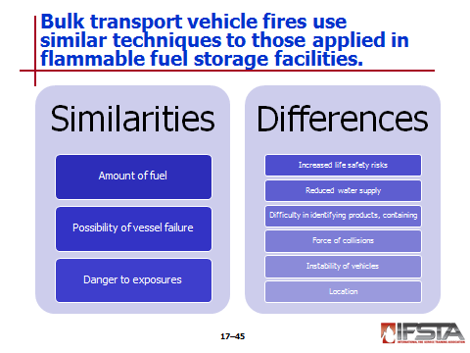
Bulk Transport Vehicle Fires

Always follow preincident plans

Techniques for extinguishment are similar to fires in flammable fuel storage facilities

Similarities

Amount of fuel available to burn

Possibility of vessel failure

Danger to exposures

Differences

Increased life safety risks to firefighters from traffic

Increased life safety risks to passing motorists

Reduced water supply

Difficulty in identifying products involved

Difficulty in containing spills and runoff

Force of collisions can weaken or damage tanks and piping

Instability of vehicles

Location of incident raises additional concerns for civilians, civilian structures

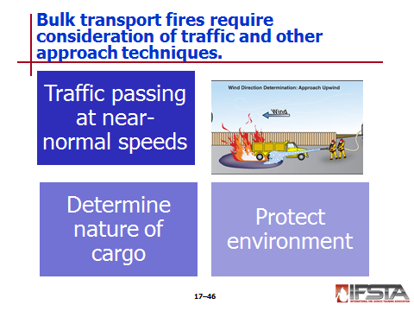
Incidents often handled while traffic passes scene at near-normal speeds

Close at least one lane of traffic in addition to incident lane

Avoid using road flares

Direct traffic, control access to scene using trained firefighters if law enforcement not available

Techniques for approaching, controlling leaks or fires

Involving vehicles and rail tank cars – Same as for storage vessels

Additional considerations for vehicle fires

Tires could fail – Causing flammable load to shift

Status, limitations of water supply vary more

May be necessary to protect trapped victims with hose streams until rescued

Determine exact nature of cargo as soon as possible

Use bills of lading, manifests, placards, or drivers

May not be found, be wrong, or drivers unable to identify cargo

Contact shippers, manufacturers responsible for vehicles

Protect environment – Prevent runoff by blocking water drains

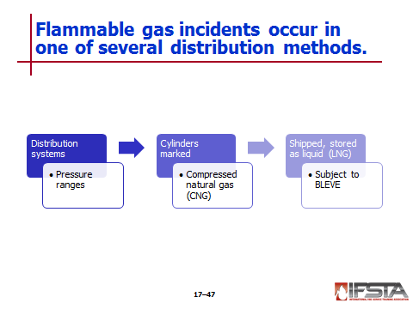
Flammable Gas Incidents

Distribution systems - Pressure

Ranges from 1,000 psi (7 000 kPa) in the distribution network to 0.25 psi (2 kPa) at point of use

Usually below 50 psi (350 kPa) in local distribution piping

May be

In cylinders marked compressed natural gas (CNG)

Shipped and stored as liquid (LNG) – Subject to BLEVE in this form
Instructor Note: This information correlates with Skill Sheet 17-II-2. More information is found at the end of this lesson outline.

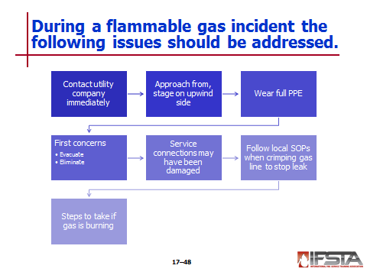
Most incidents generally caused by excavation equipment breaking through underground pipes

Contact utility company immediately

Approach from, stage on upwind side – Even if not ignited

Wear full PPE, be prepared in event of explosion, accompanying fire

First concerns

Evacuation of area immediately around break

Evacuation of area downwind

Elimination of ignition sources

Service connections may have been damaged – Check surrounding buildings for odor of gas inside

Follow local SOPs when crimping gas line to stop leak

If gas is burning

Do not extinguish flame

Use hose streams to protect exposures if needed

Contact utility company, attempt to shut off pressurized gas supply

Request hazardous materials team if available
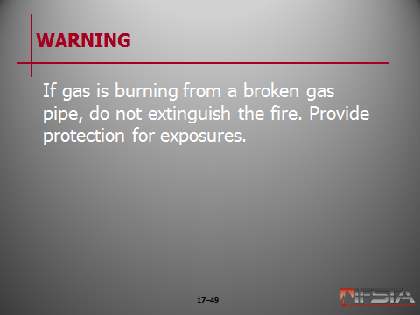
WARNING!: If gas is burning from a broken gas pipe, do not extinguish the fire. Provide protection for exposures.

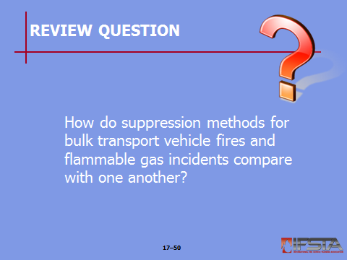
Review Question: How do suppression methods for bulk transport vehicle fires and flammable gas incidents compare with one another?
See pages 1075-1076 of the manual for answers.

Section III: Skill Sheets

SKILL SHEETS
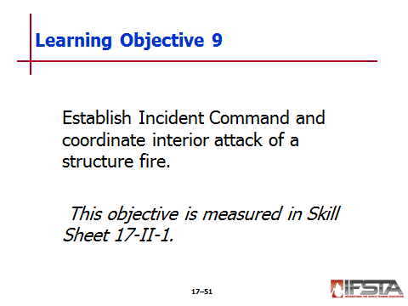
pp. 1098 Objective 9 — Establish Incident Command and coordinate interior attack of a structure fire.

Skill Sheet 17-II-1

For this skill sheet, students will perform the skills to establish Incident Command and coordinate interior attack of a structure fire

This skill sheet can be found in the Skills Evaluation Checklist 17-II-1 on the curriculum flash drive

This checklist corresponds with the information on pp. 1064-1066 of the manual
pp. 1099 Objective 10 — Control a pressurized flammable gas container fire.

Skill Sheet 17-II-2

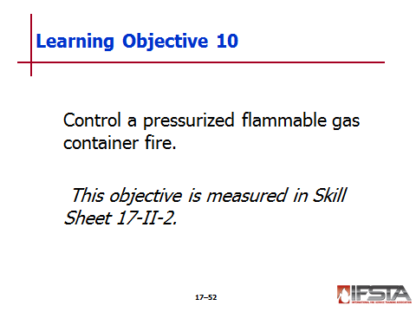
For this skill sheet, students will perform the skills to control a pressurized flammable gas container fire

This skill sheet can be found in the Skills Evaluation Checklist 17-II-2 on the curriculum flash drive

This checklist corresponds with the information on pp. 1076 of the manual

Section IV: Summary and Review

IV. SUMMARY AND REVIEW

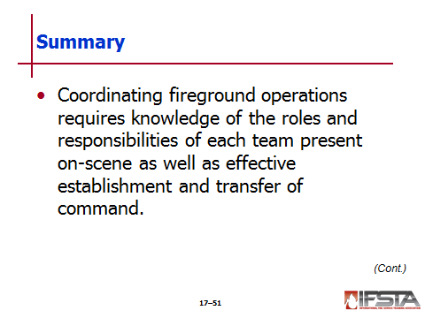
Chapter Summary

Coordinating fireground operations requires knowledge of the roles and responsibilities of each team present on-scene as well as effective establishment and transfer of command.

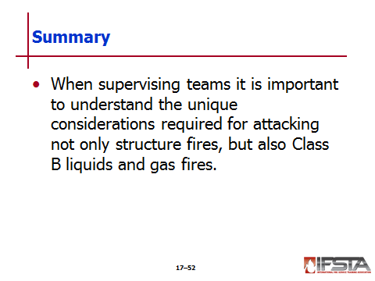
When supervising teams it is important to understand the unique considerations required for attacking not only structure fires, but also Class B liquids and gas fires.

Review Questions

What are the priorities that must be considered when beginning fireground operations? (1057-1058)

What are the fireground roles a firefighter II may need to coordinate at an incident? (1058-1063)

How should Command be established at an incident? (1064-1066)

What hazards may be present at fires in underground spaces? (1066-1068)

What safety precautions should be taken at flammable/combustible liquid fire incidents? (1069-1070)

How do suppression methods for water-based, and non-water-based suppression systems differ? (1071-1072)

What are the ways water can be used to control Class B fires? (1073-1074)

How do suppression methods for bulk transport vehicle fires and flammable gas incidents compare with one another? (1075-1076)

